07-03-2025

Deep learning DOCUMENTATION

# Perceptron

* Algorithm
* Supervised ml
* Mathematical model or function

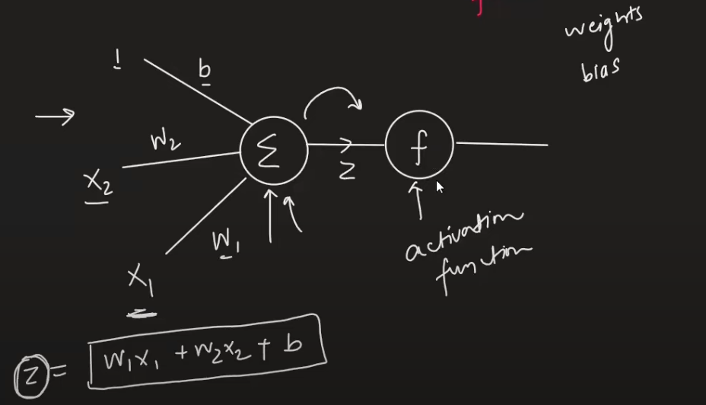

* Activation function is used to bring the value of z in some range like (0,1) or (-1,1)

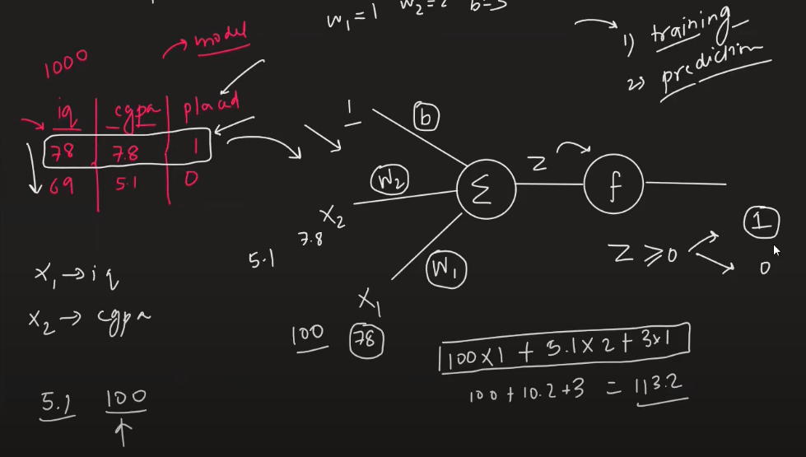

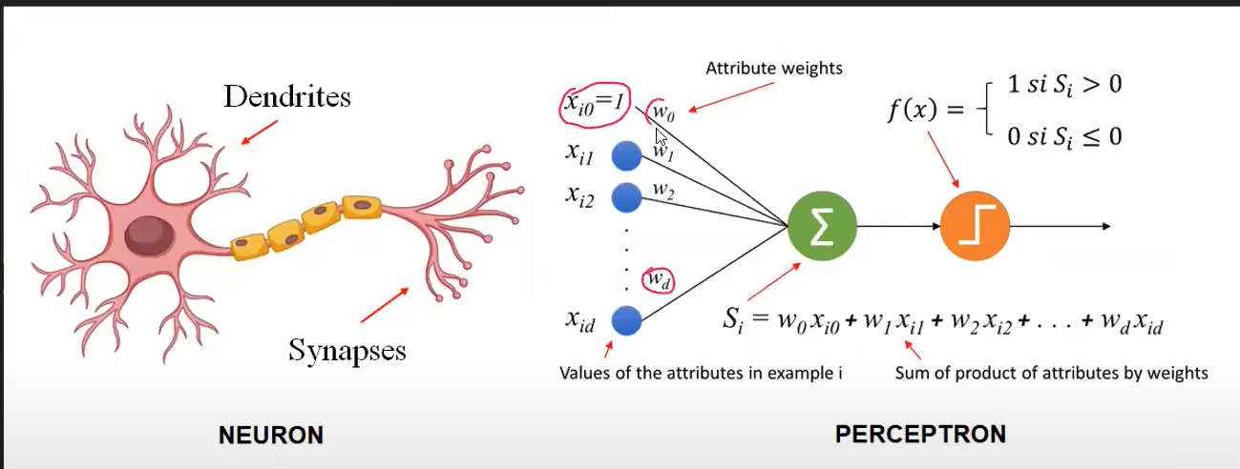

## Interpretation

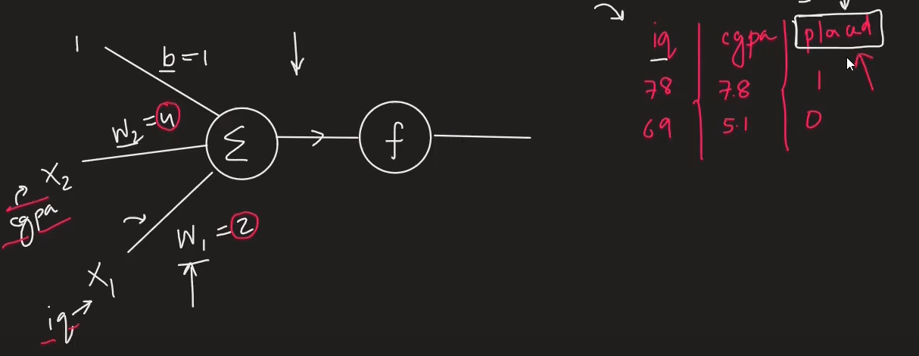

W1 and W2 are weights that explain what is the importance of feature to predict the outcome in our case iq and cgpa. {Feature Importances}

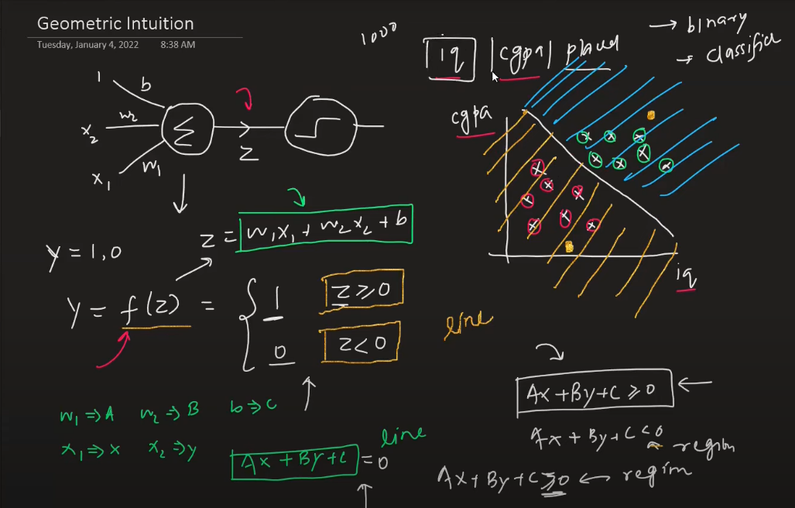

* 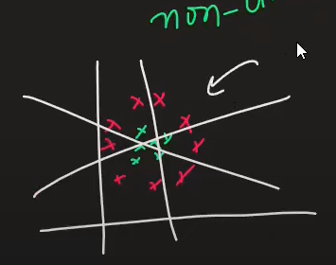Perceptron is like a line for creating a region and dividing the class. {Binary Classifier}
* For 2 d – line
* For 3 d – plane
* For 4 d onwards – hyperplane
* Limitation – works on linear or sort of linear only, perceptron will fail if u have nonlinear data
* E:\DeepLearning\1_Perceptron-Demo.ipynb

Check this file to clearly understand weight and b calculated nothing but m and c in line (y = mx+c)

# How to train a Perceptron

1 Using Perecptron trick

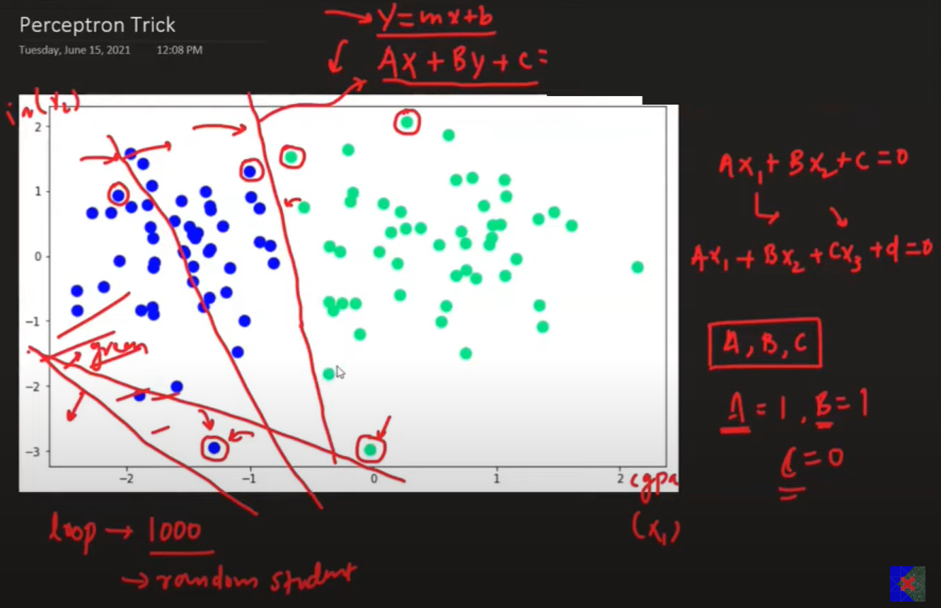 Run a loop for min 1000(epochs) time ask each point classified properly if yes then don’t change the line if no then change it.

Transformation

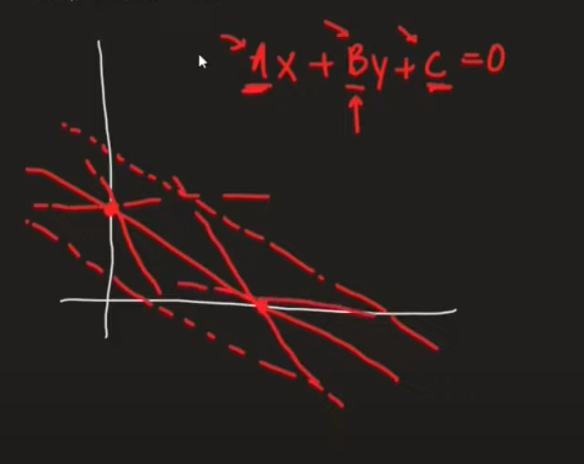If you change the value of c it is like moving upward or downward (c > then down c < up [dotted line])

Llly for a and b check in desmos tool

If a point is not correctly classified , based on the region you will add or subtract such that the line will correctly classify the point

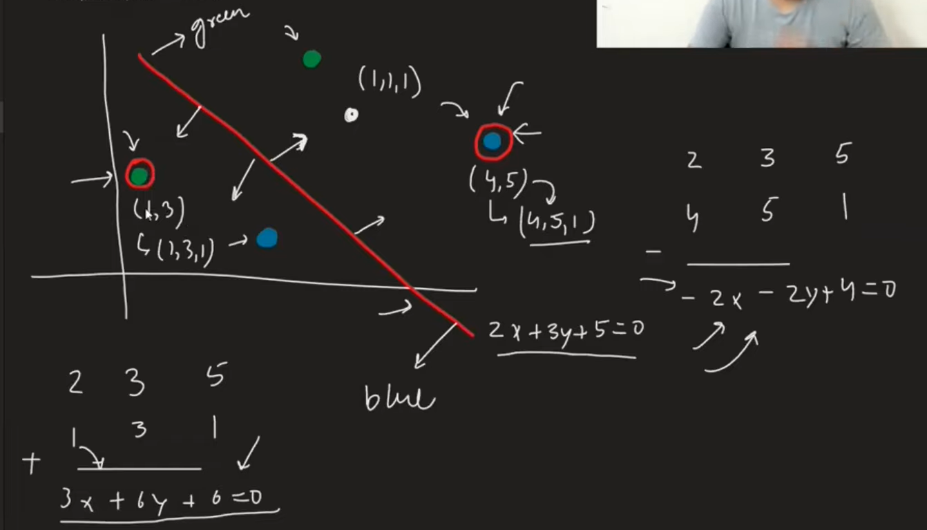

You usually don’t multiply directly the coefficient of line with the point , you multiply the point with learning rate usually 0.01 so that transformation happens in a such a way that points classify correctly.

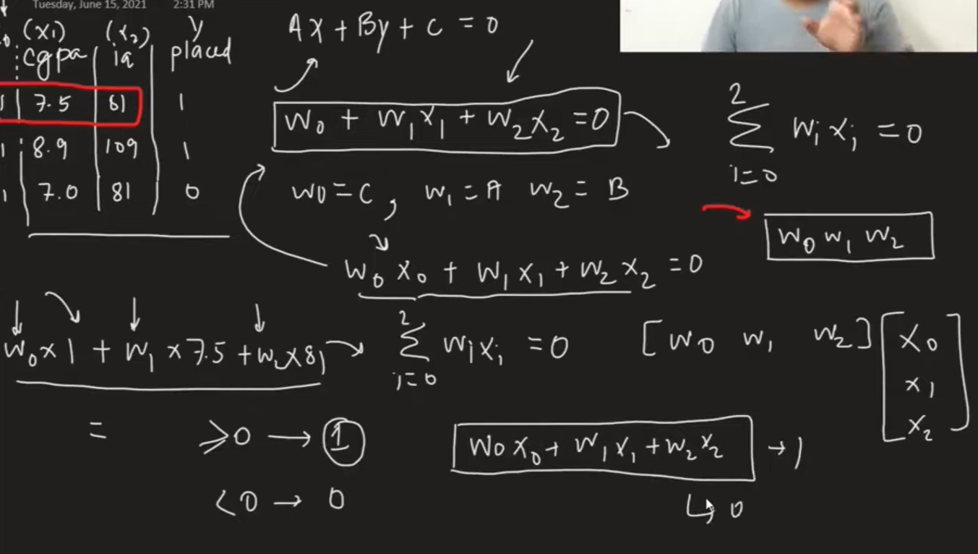

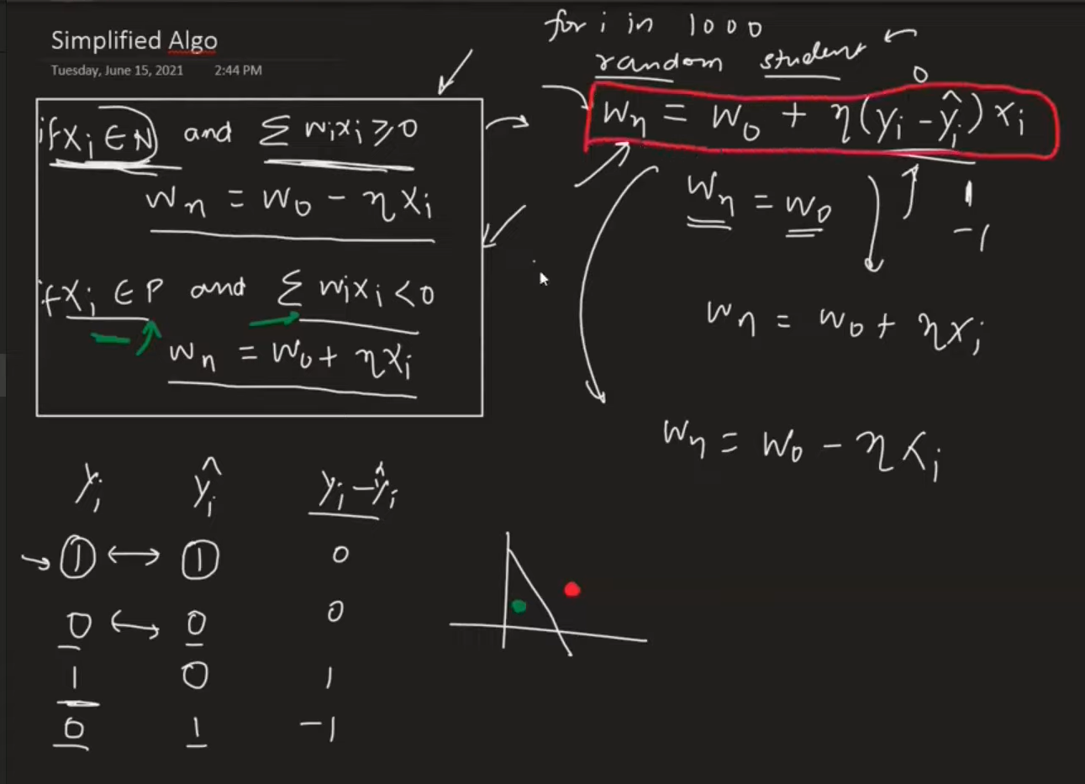

1. Perceptron Loss Function

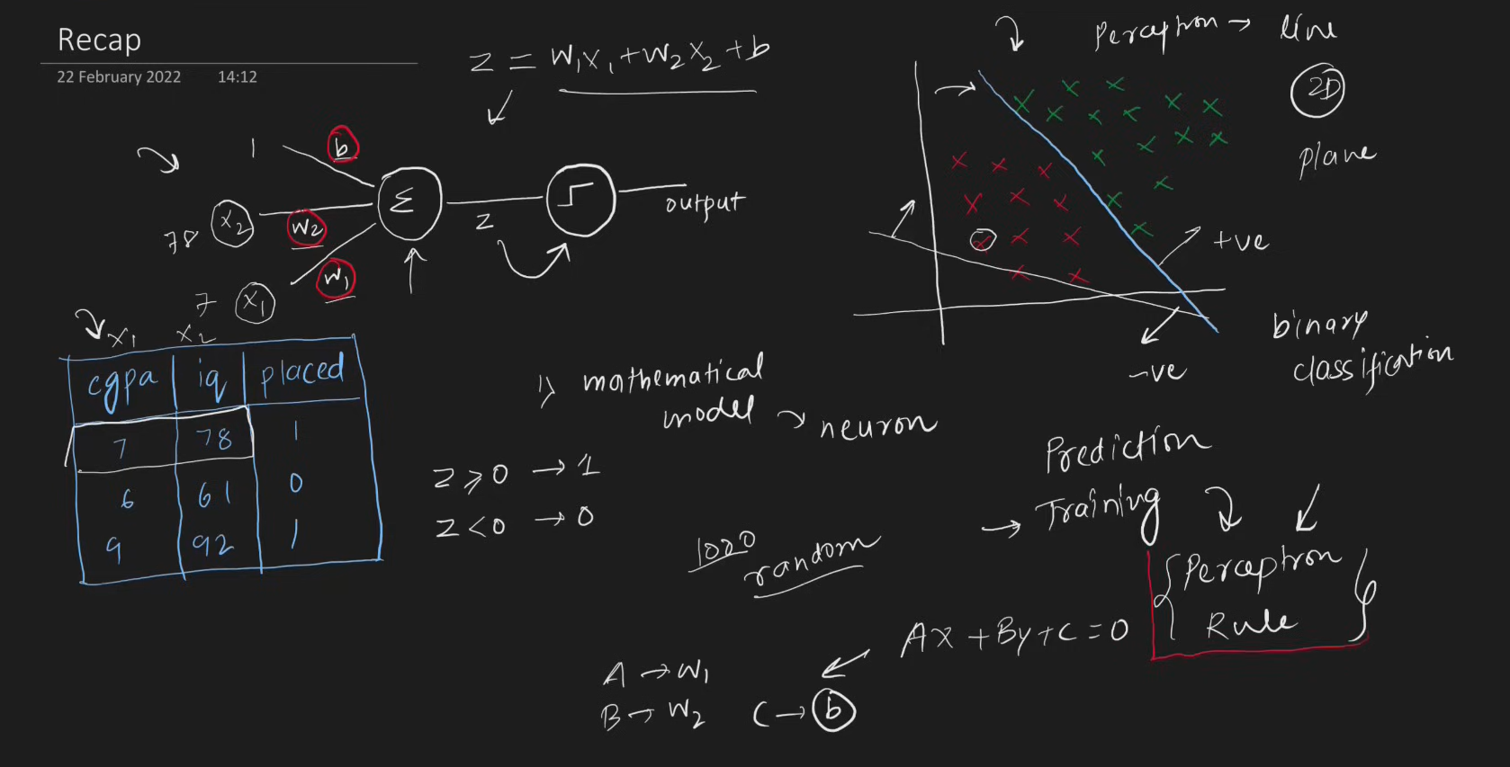

* Problem with perceptron trick
  + - If the value does not change in w1 ,w2 and b2 the line will not move or else the line will move if any changes
    - You can get any line and you cant quantify your result and you cant tell which line is best
    - Convergence problem possibility (like using same value for every epoch , it will not happen but there is a possibility )

Loss Function

* + - Is a way to tell that how the model is performing good or bad
    - It will give u a number that will tell how good is it
    - Simple term , it is a function which gives minimum value

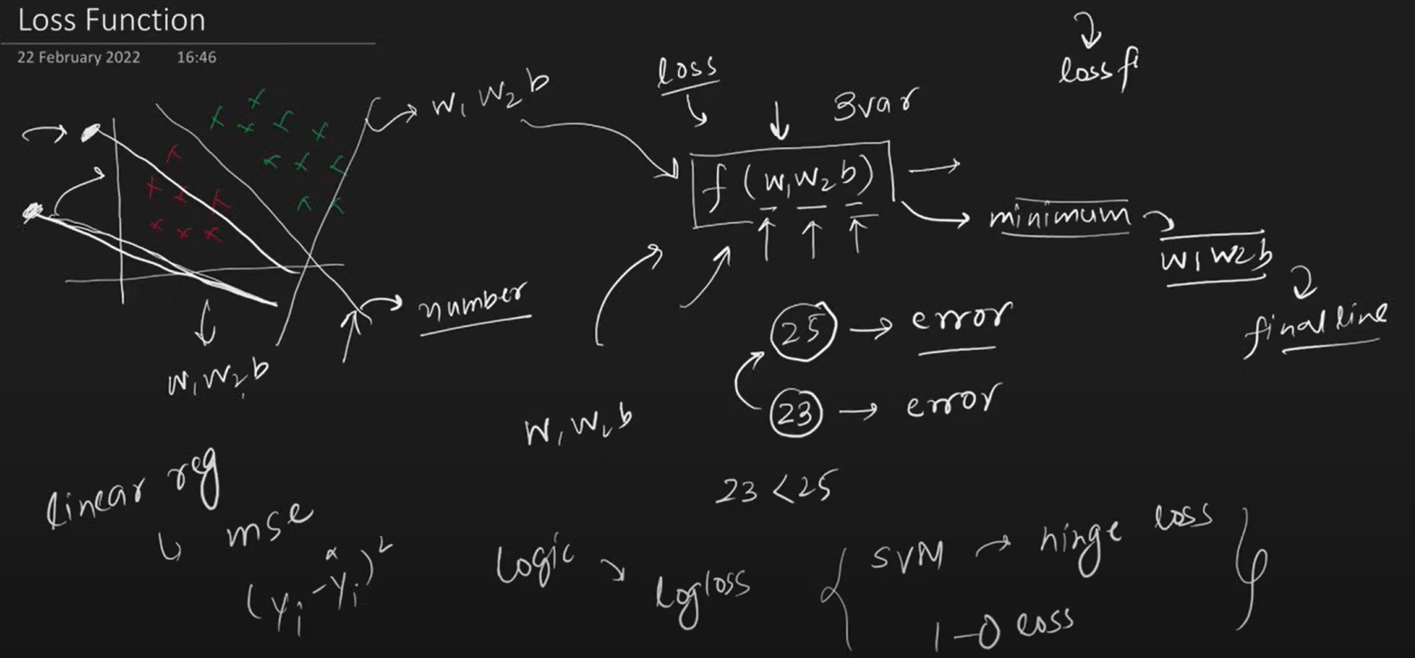

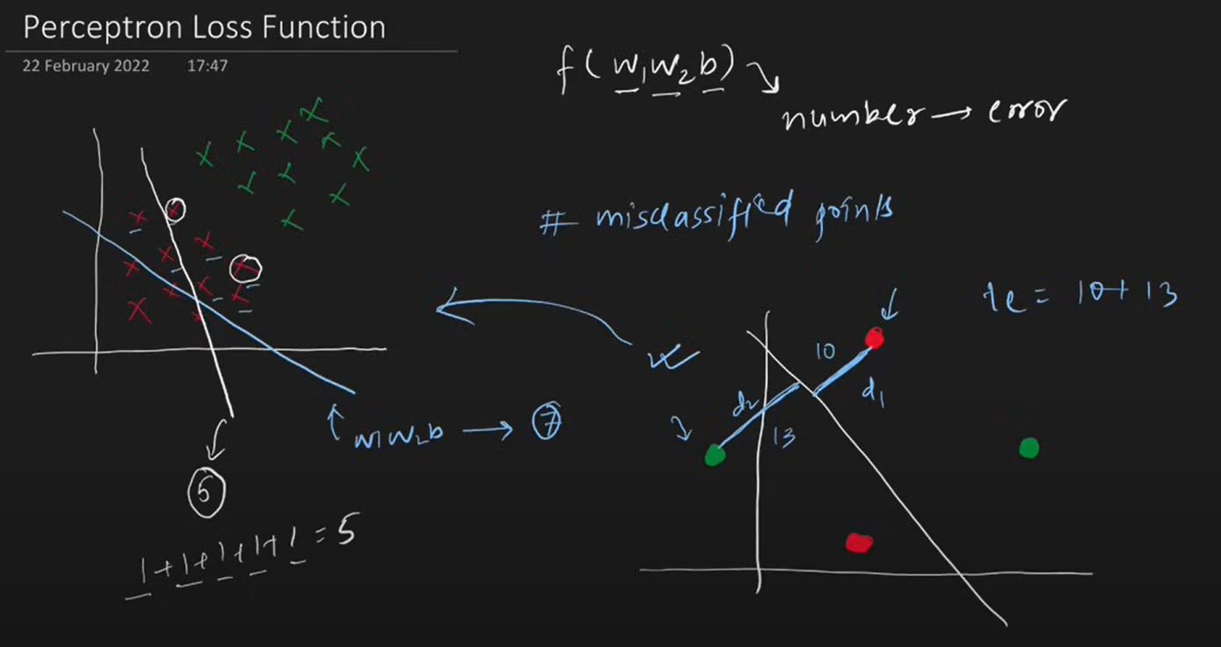

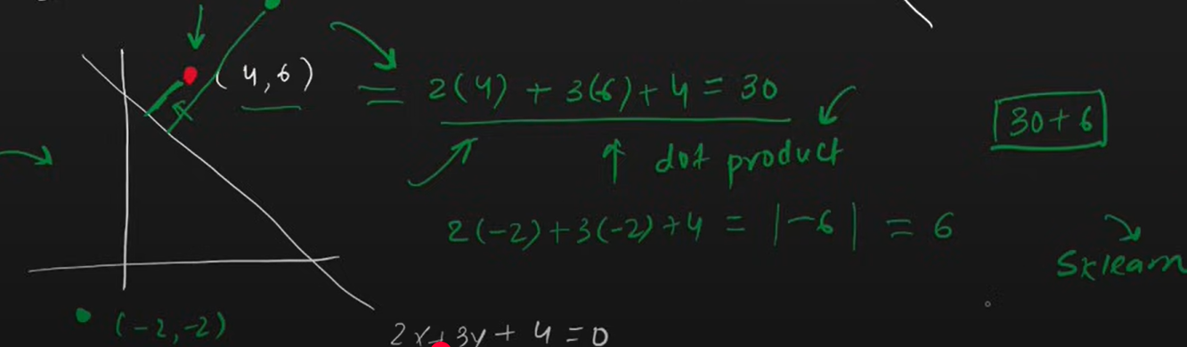

The Loss function implemented in sklearn for perceptron Is

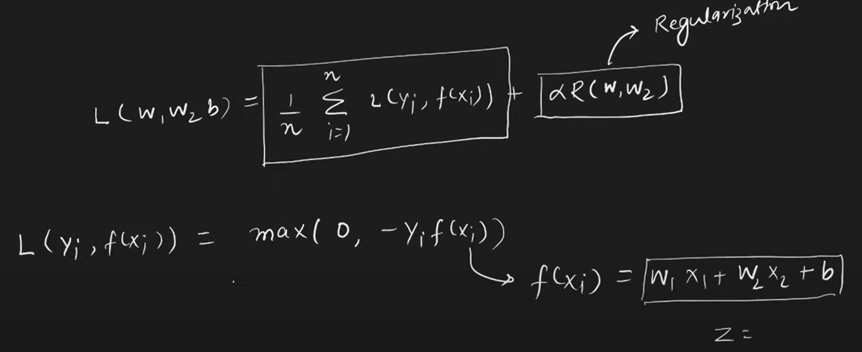

N – number of rows

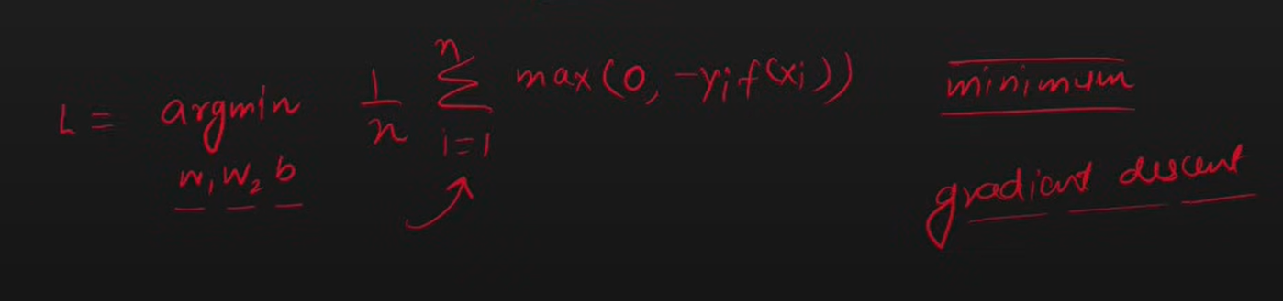

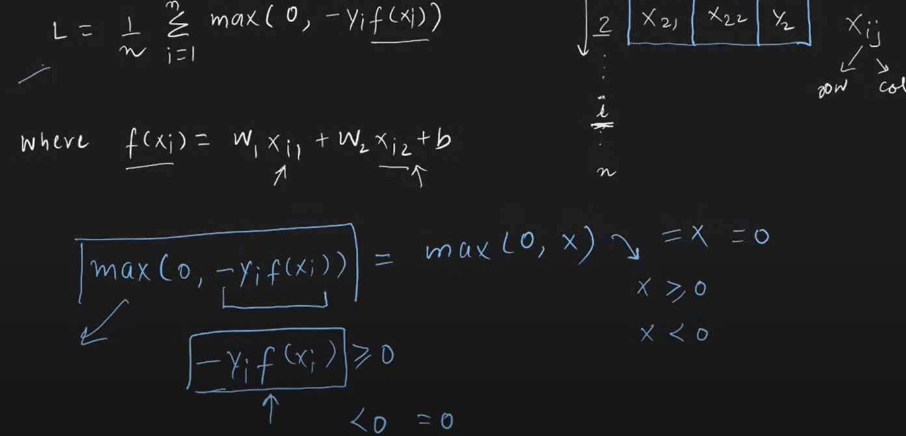

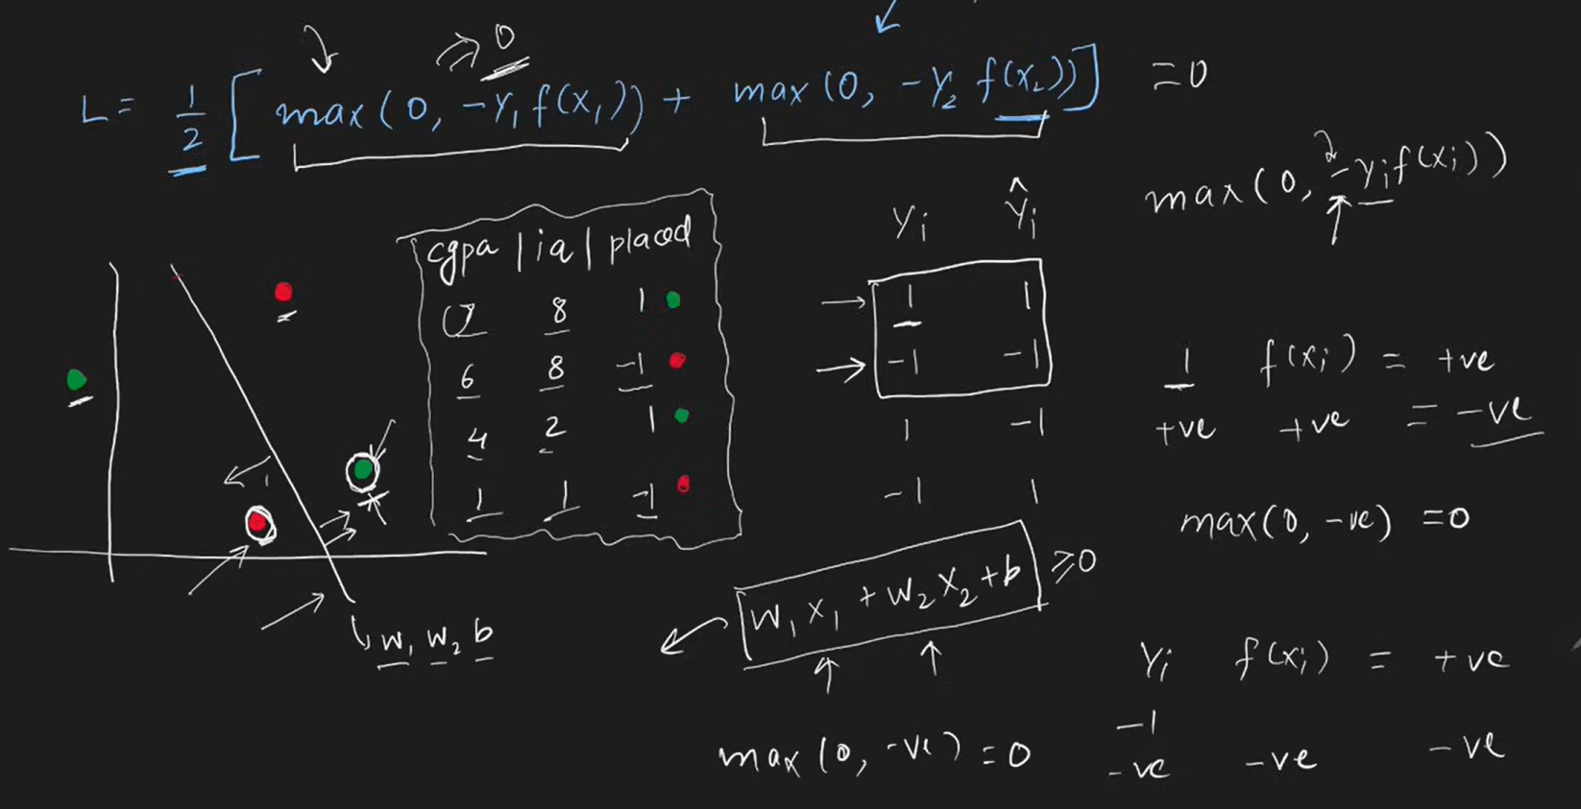

If point is correctly classified then that point does not contribute in the loss function

Gradient Descent Optimization Algorithm

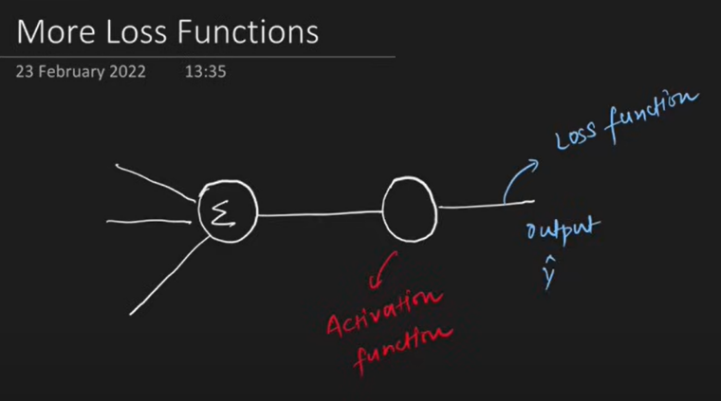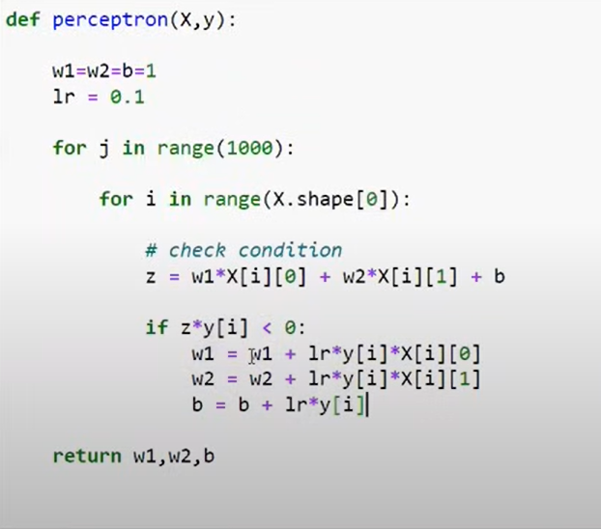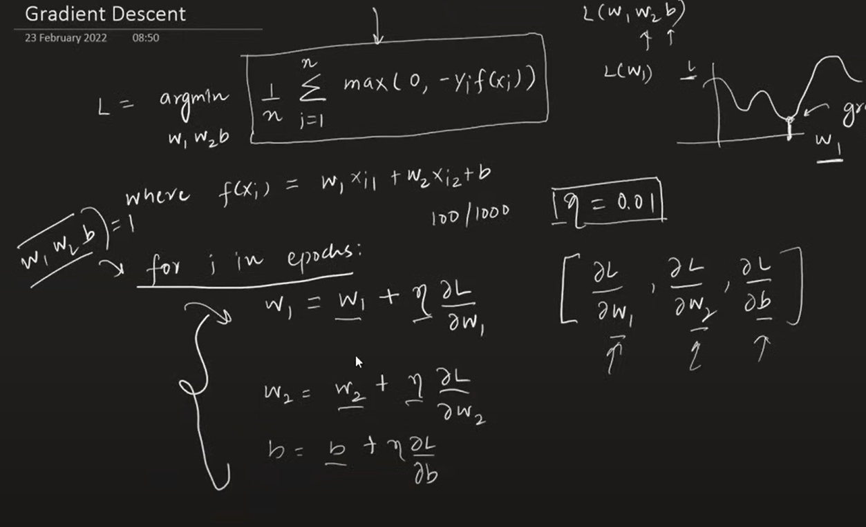

{ MORE FLEXIBLE ,MATHEMATICAL MODEL}

|  |  |  |
| --- | --- | --- |
| Activation Function | Loss Function | OUTPUT |
| STEP | Hinge Loss | 1,-1 (binary classifier) |
| SIGMOID | Binary Cross Entropy /log loss | 0,1 (binary classifier) |
| SOFTMAX | Categorical Cross Entropy | Multiclass prob |
| Linear | MSE | ANY NUMBER |

**NOTE**: PERCEPTRON IS ALSO CALLED AS LOGISITIC REGRESSION WHEN YOUR ACTIVATION FUNCTION IS SIGMOID AND LOSS IS BCE

# Problem with Perceptron

Works only with linear data not on non linear data because essentially perceptron is a linear model.

The problem with Perceptron lies in their limitation to learn complex patterns and functions, especially those that are not linearly separable. A Perceptron is a single-layer neural network with binary outputs, and it can only solve problems where the data points are linearly separable. If the data is not linearly separable, a Perceptron cannot converge and find a solution.

<https://playground.tensorflow.org/>

# MLP Notation

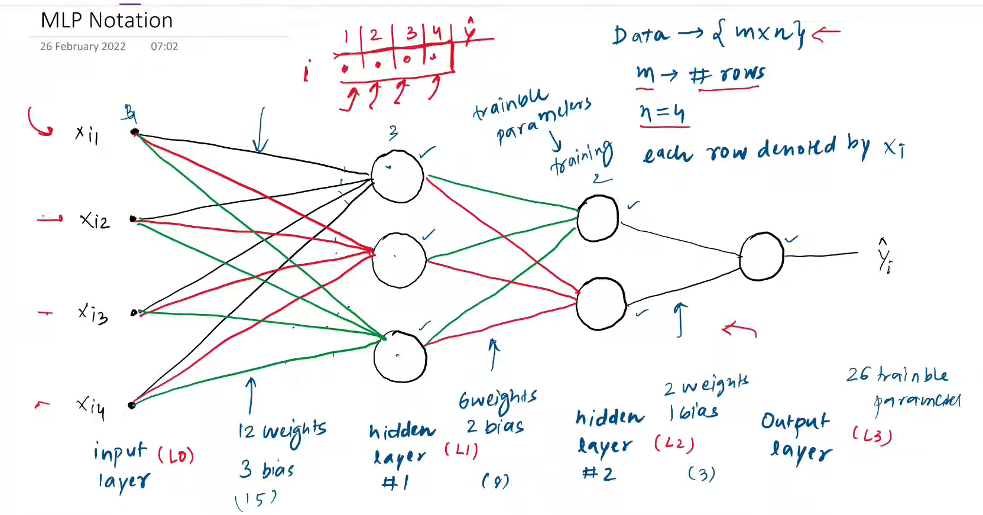

I – layer

j- node

<https://youtu.be/H0_3SJh4Rqs?si=0gm1JLjvhItYEN1g>

# MultiLayer Perceptron | MLP Intuition

A Multi-Layer Perceptron (MLP) is a type of artificial neural network characterized by its multiple layers of nodes (neurons). It consists of an input layer, one or more hidden layers, and an output layer. Each connection between nodes is associated with a weight, and each node applies an activation function to the weighted sum of its inputs. MLPs are trained using algorithms like backpropagation to learn and make predictions.

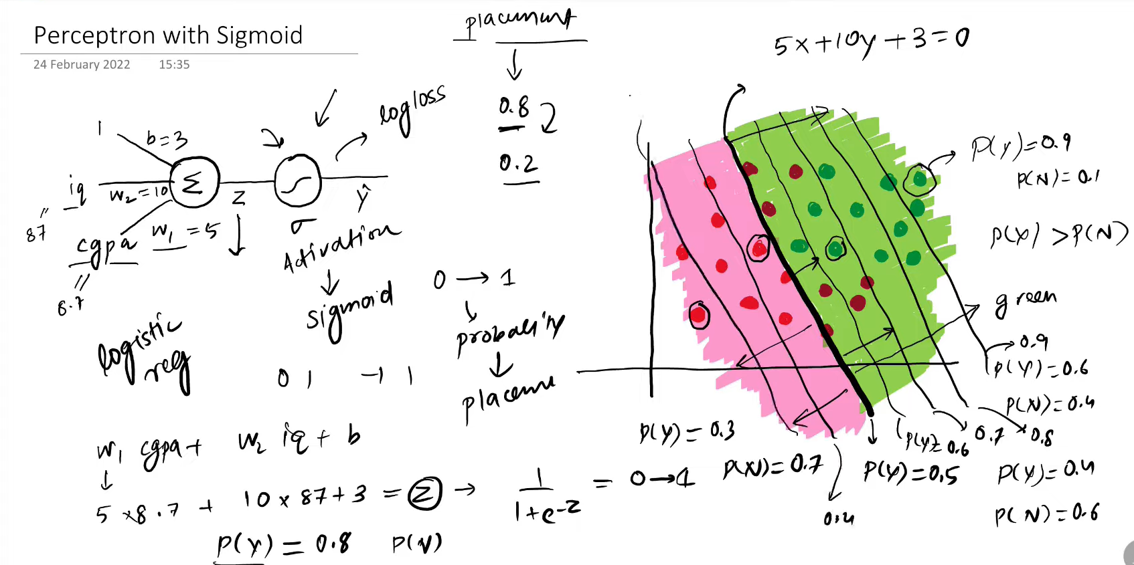

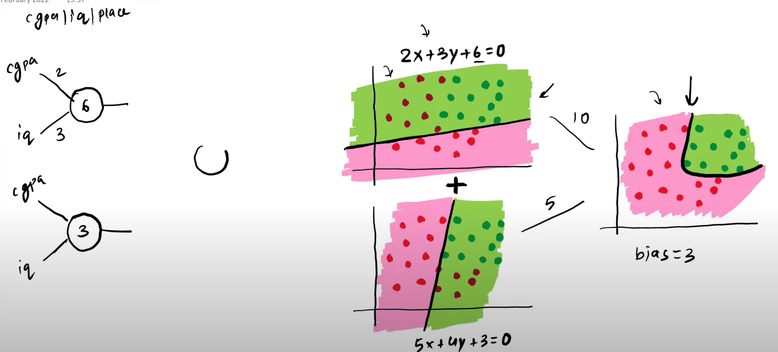

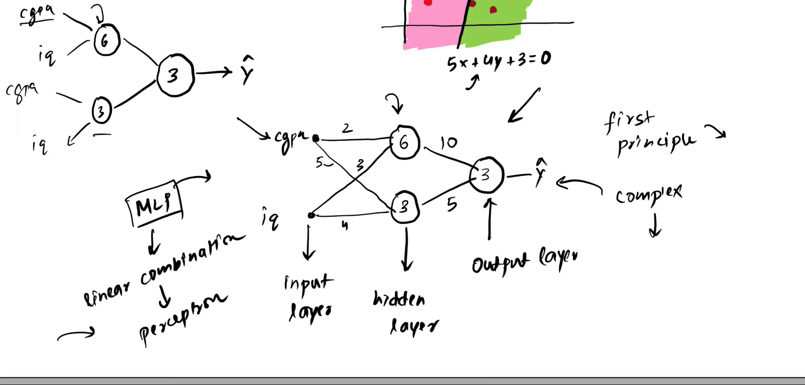

How to get more accurate result | Change Architecture

* Add more node to capture more non linear decision boundary

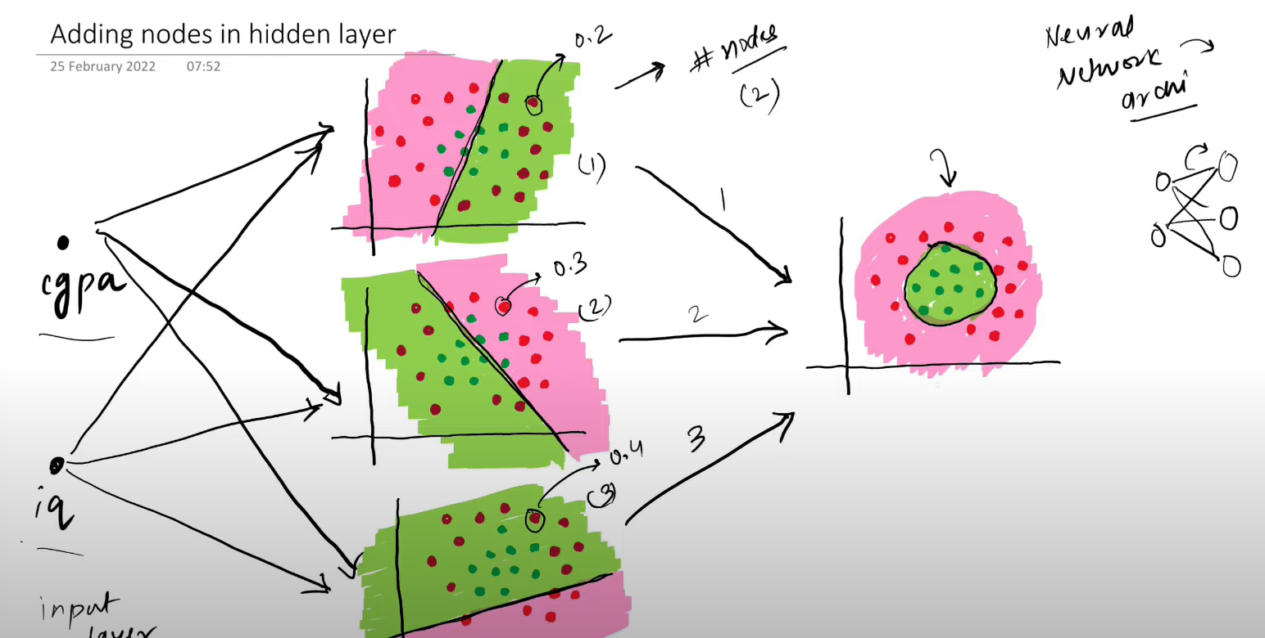

* Add more input column if you have
* Adding nodes in output node (Generally when u work on multi class classification)
* Add more hidden layer to capture more complex relationship

# Forward Propagation | How a neural network predicts output?

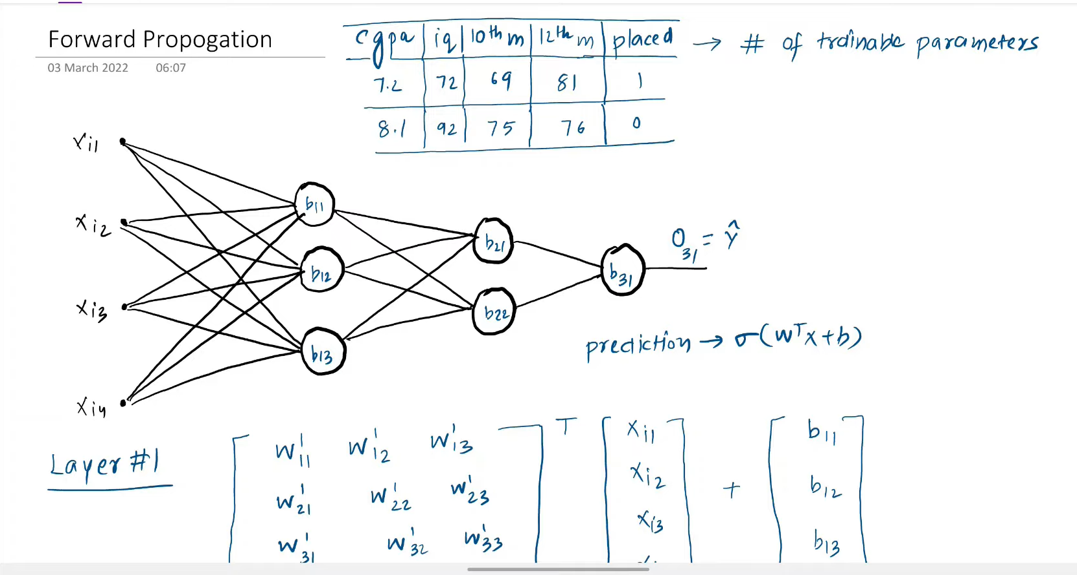

There are 26 Trainable parameter

Input layer to first hidden layer 4 *3 = 12 +3 biase similarly

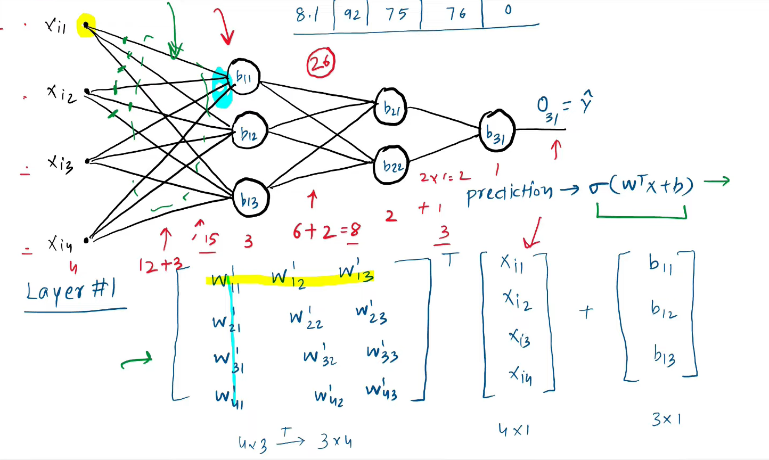

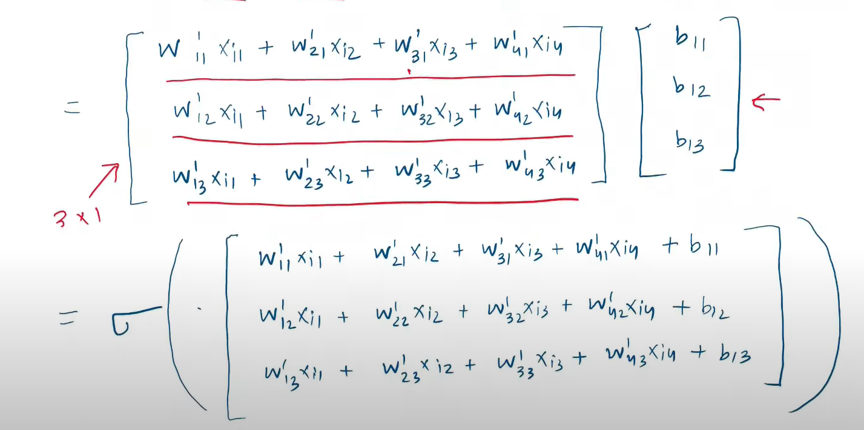

The sigmoid function will give you output as o11 , o12,o13

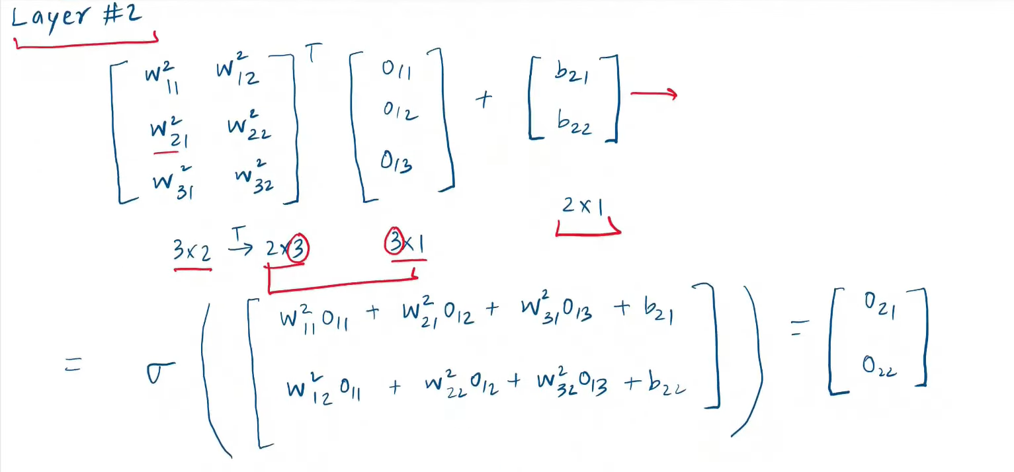

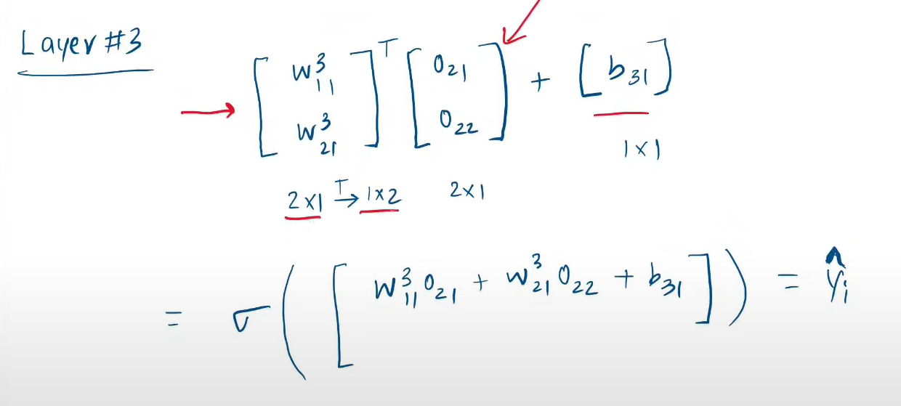

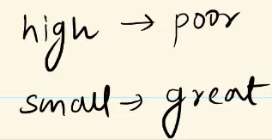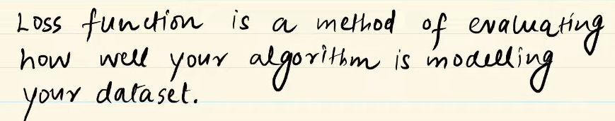**Loss Functions in Deep Learning**

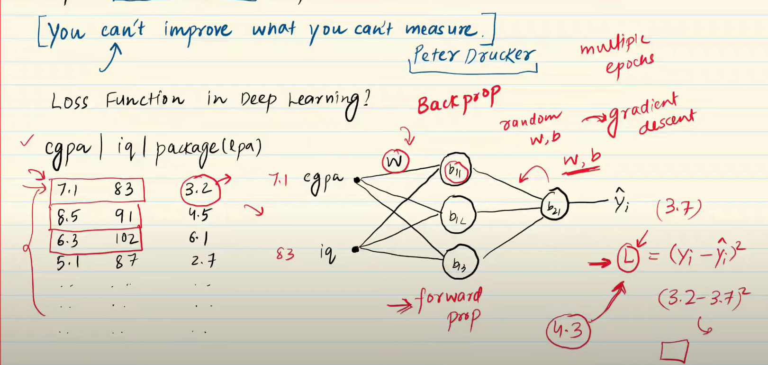

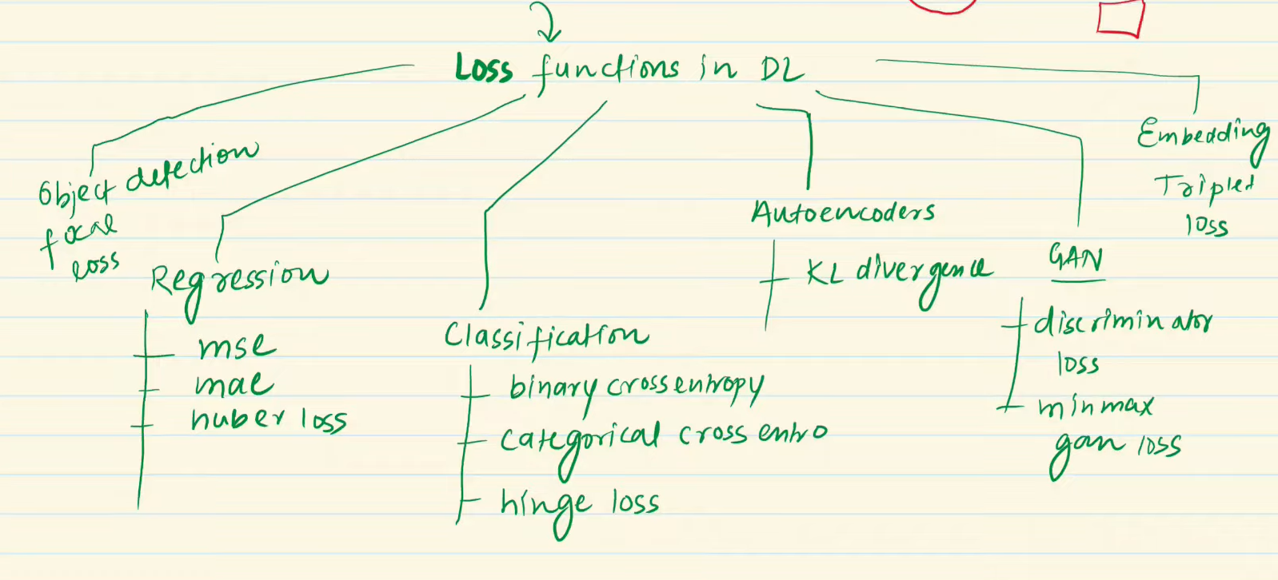

Loss function vs Cost Function

* Lf – calculate on single training example
* CF – entire training or batch

Loss Function

Regression – MSE – If you have no outlier then use thus

MAE – Or else use this , problem in calculating Gradient but possible

HuberLoss- if no outlier then behave like mse and or else mae (It lies between mae and mse , if you have more outlier in data then use this.

Classification

-BCE -u have two classes ,may have multiple minima and it is also differentiable

-CCE- u have multi classes,activation will be softmax ez1/ez1+ez2+ez3..

-SCCE(SPARSE) – OHE IS LIKE 1,2,3 not like 001,100,010 , it is fast

# Backpropagation in Deep Learning | Part 1 | The What?

Backpropagation, short for "backward propagation of errors," is an algorithm for supervised learning of artificial neural networks using gradient descent. Given an artificial neural network and an error function, the method calculates the gradient (Partial Derivative ) of the error function with respect to the neural network's weights.

STEPS:

* Init w,b {different techniques these}
* You select a point or row or run a loop
* Predict (Forward propagation)(Dot product)
* You choose a loss function
* Weight and baises update using GD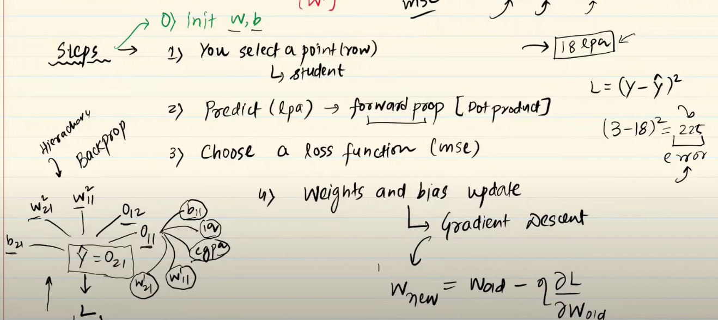

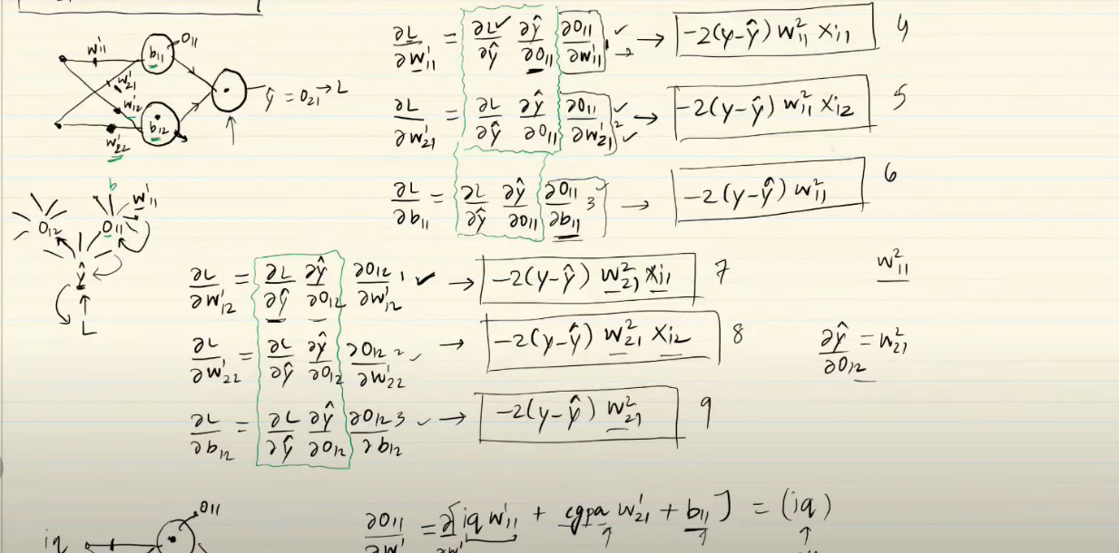

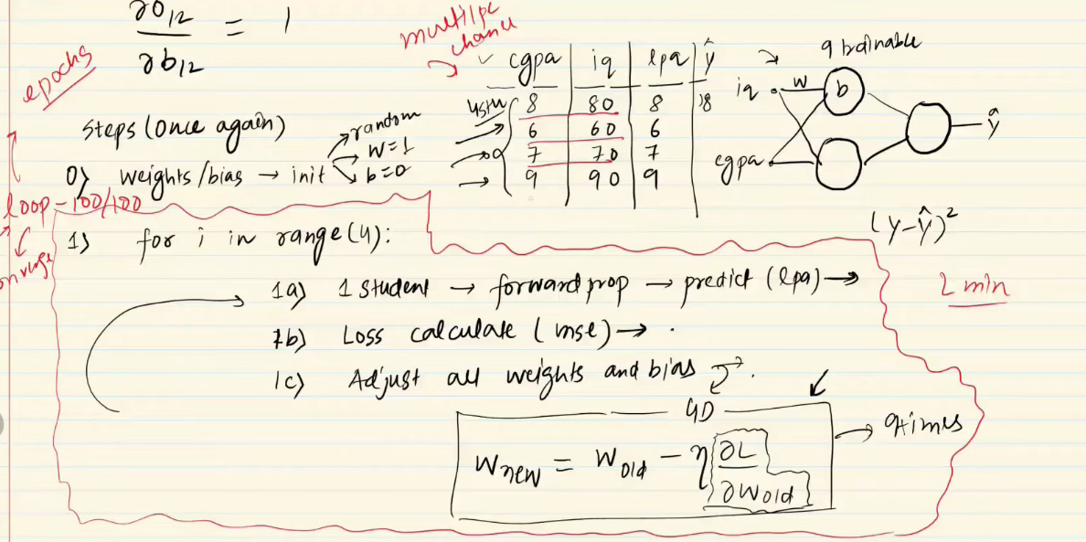

**Backpropagation Part 2 | The How**

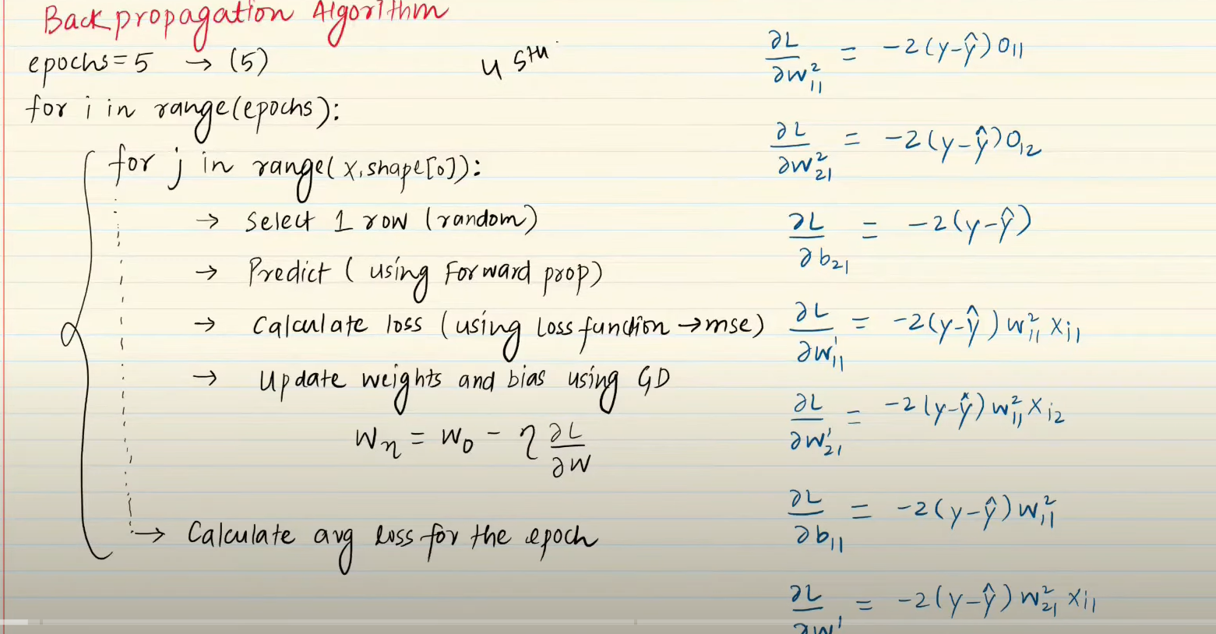

**E:\DeepLearning\4_Back_Propagation_Regression.ipynb**

**Backpropagation Part 3 | The Why**

* Loss function is a function of all trainable param.
* 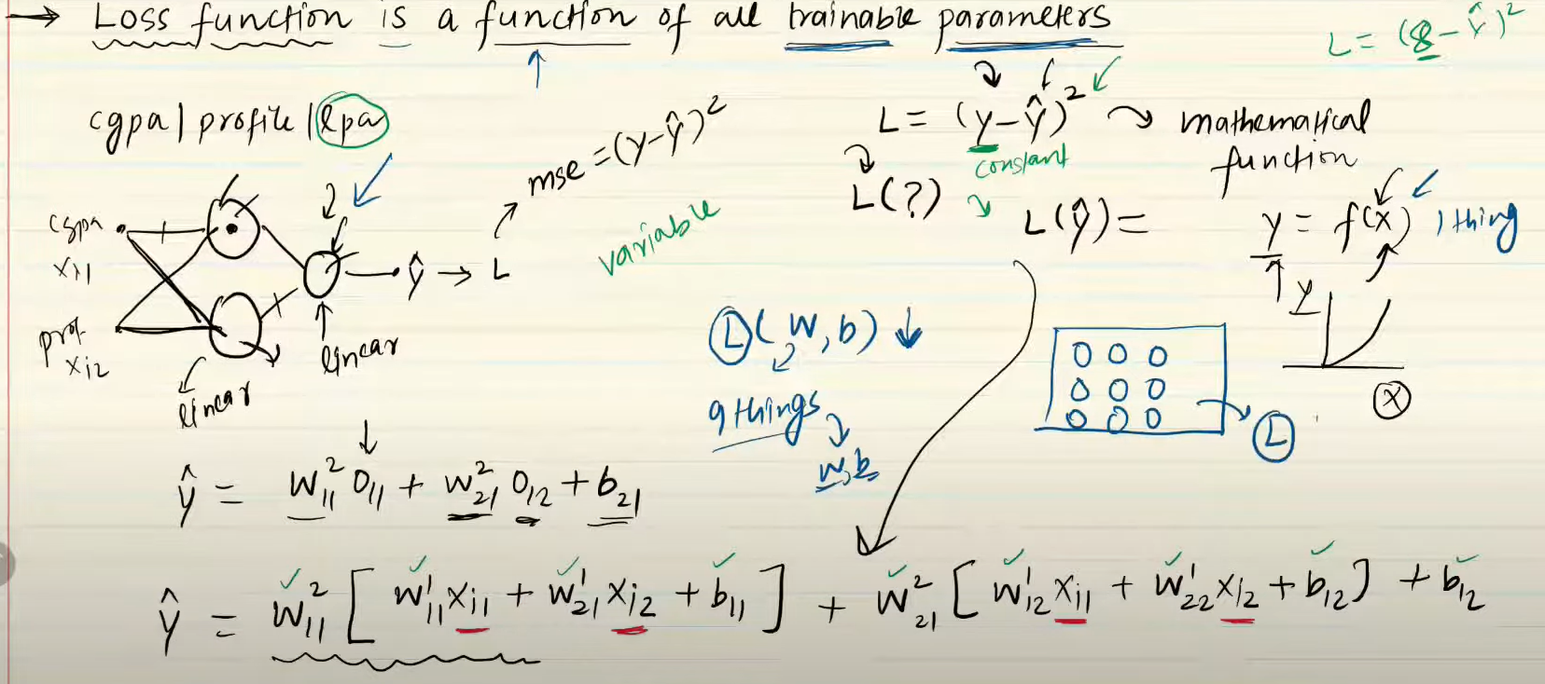
* If the function is differeitable with one then it is deraivtive or else gradient for more
* Derivative – rate of change (for example when u change x , correspomding change will be visible in y)
* Derivative at a point

# MLP Memoization

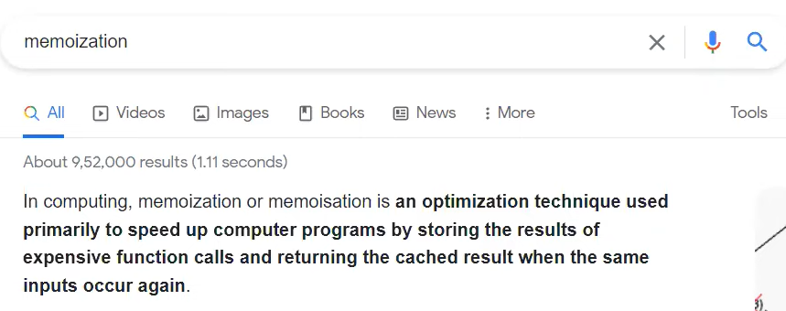

* Backpropagation is two things - chain rule + Memoization

**Gradient Descent in Neural Networks | Batch vs Stochastics vs Mini Batch Gradient Descent**

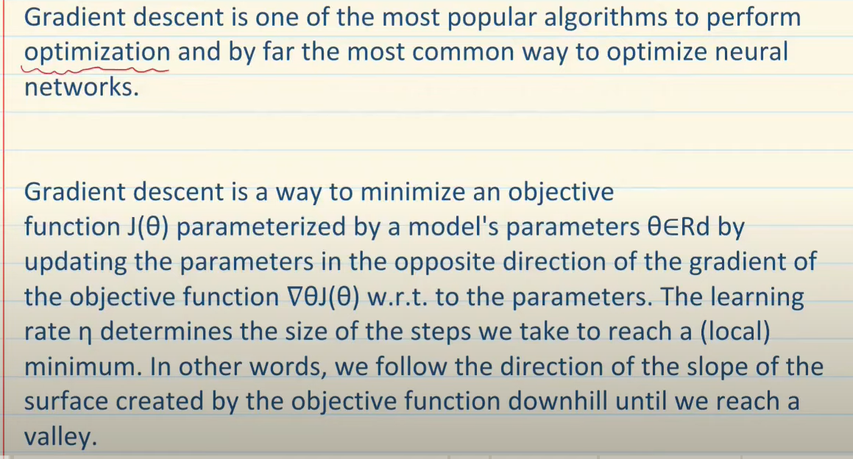

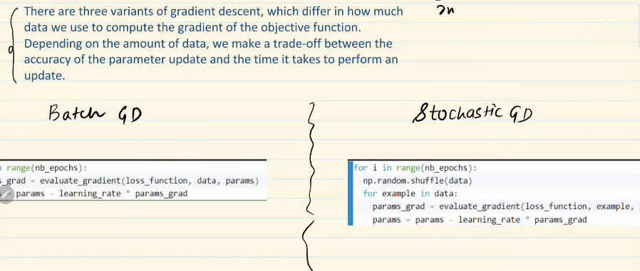

BATCH GD OR VANILLA

* You take entire dataset and then u make update
* The weight will update for the no of epochs
* No of epochs = no of updates

STOCHASTIC GD

* U decide epoch
* U shuffle the data and take one point randomly
* You predict and find loss
* Update
* Epochs 10 and 50 rows then 500 times weight will be udpates
* Frequency of updating weight is higher

Which is Faster (GN same no of epochs)

* Batch GD
* If you put batch_size = 1then it is SGD or n then BGD

model.fit(X_scaled,y,epochs=500,batch_size=1,validation_split=0.2)

Which is the faster to converge?

* SGD
* Bcz it take more updates

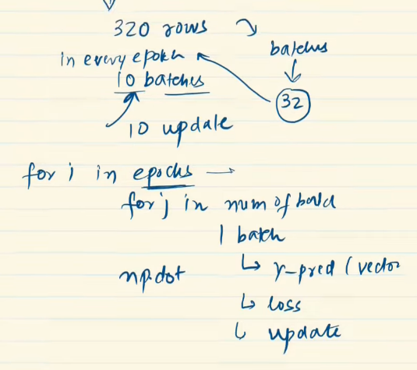 [NOTE : The loss reduced in SGD is unstable more compared to BGD ]

MINI BGD

* U create small batches
* It is middle of both mentioned above

FAST

>BGD>MBGD>SgD

CONVERGNECE

Bgd<mbgd<sgd

Why batch_size is multiple of 2 ?

* RAM EFFECTIVELY CAN BE USED
* OPTIMIZATION TECHNIQUE
* MAKE CODE FASTER

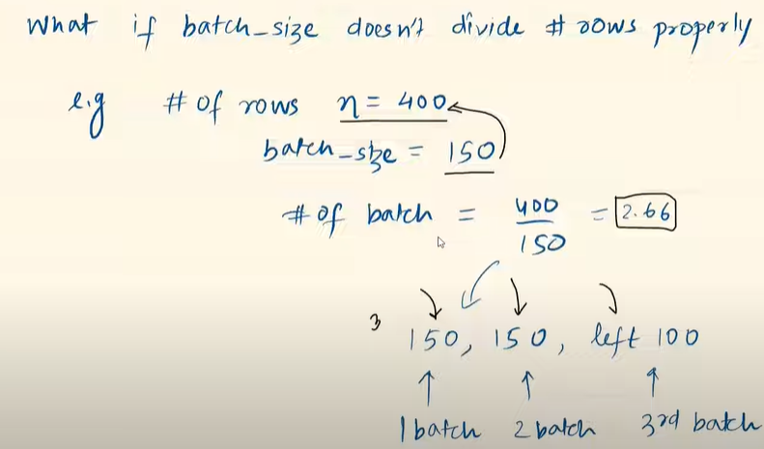

**Vanishing Gradient Problem in ANN | Exploding Gradient Problem |**

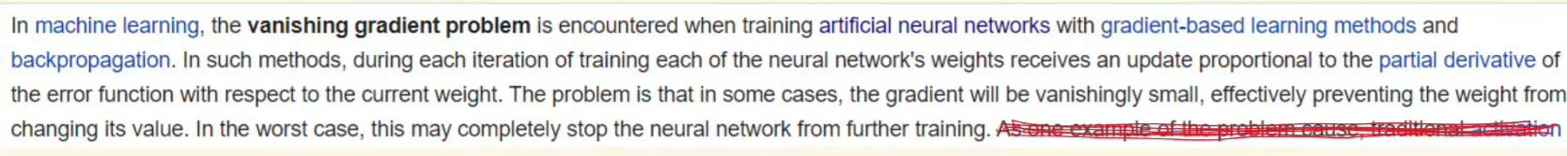

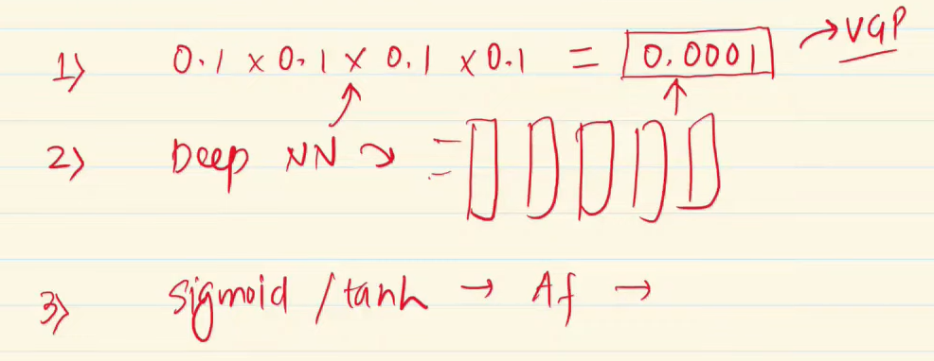

How to recognize the problem is happening?

* Focus on loss – no change > VGP
* Weights – plots

How to handle ?

* Reduce model complexity
* Using RElu activation function(-1000 to 1000 from 0 to 1000)
* Proper Weight Init (Glorat or xavier)
* Batch Normalization
* Using Residual Network a special type of network

Exploding Gradient Problem - Opposite of Exploding Problem (Faced in RNN) (Gradient Clipping can be used for solving)

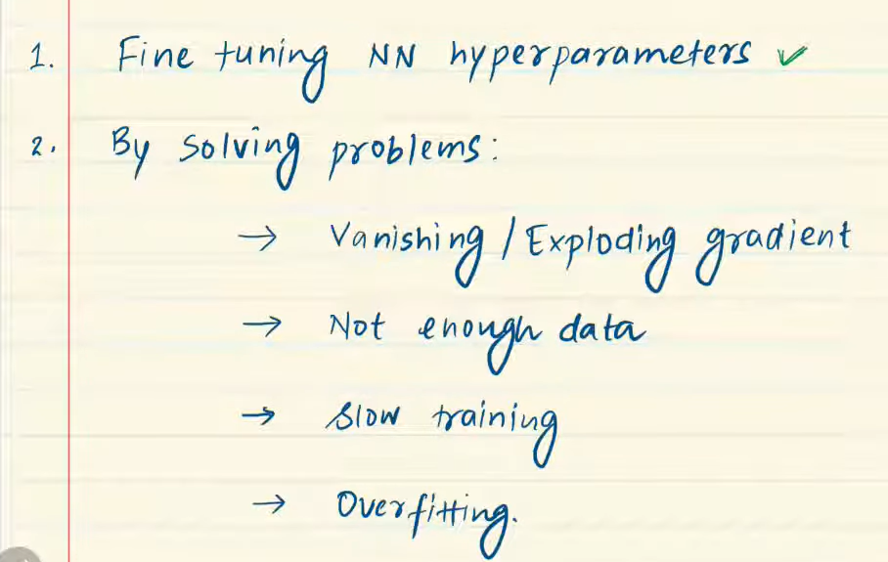**How to Improve the Performance of a Neural Network**

1 – Hidden Layers, No of neurons per layer, Learning Rate , Optimizer, Batch Size ,Activation function and epochs

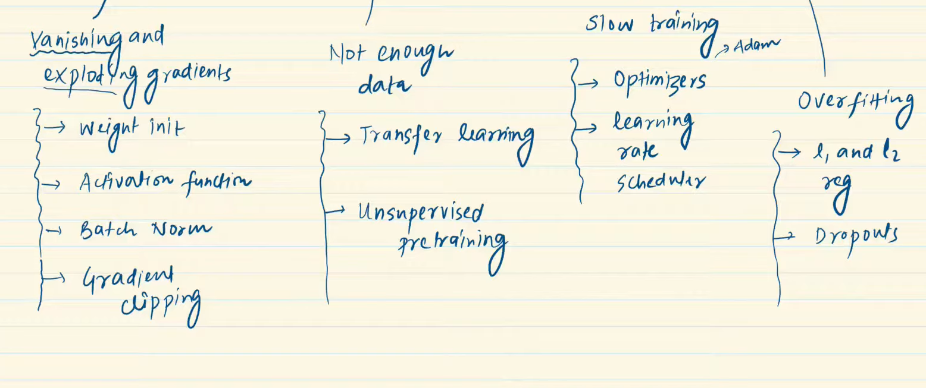

**Early Stopping in Neural Networks**

It is a mechanism to detect the overfitting and stop it , implemented using callbacks in keras

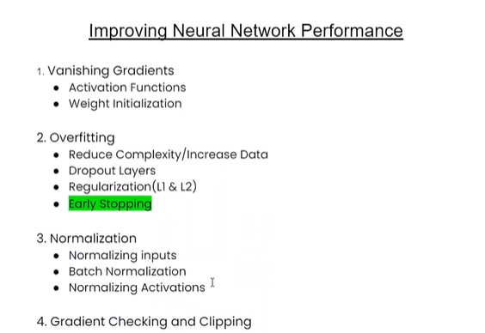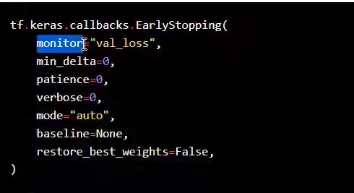

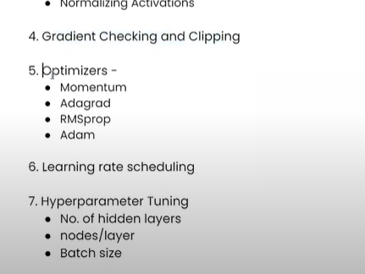

**Data Scaling in Neural Network | Feature Scaling in ANN**

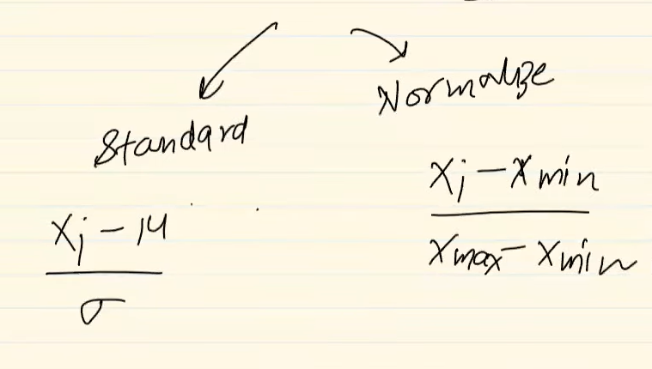-1 to 1- standaridze

0 to 1- Normalize

**Dropouts in ANN | When the model is Overfitting**

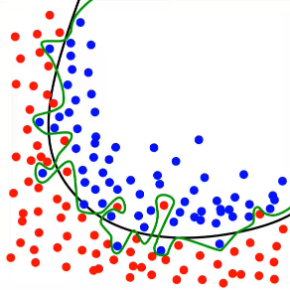To reduce Overfitting

* Add more data
* Reduce complexity of the model
* Early Stopping
* Regularization (l1 and l2)
* Dropouts

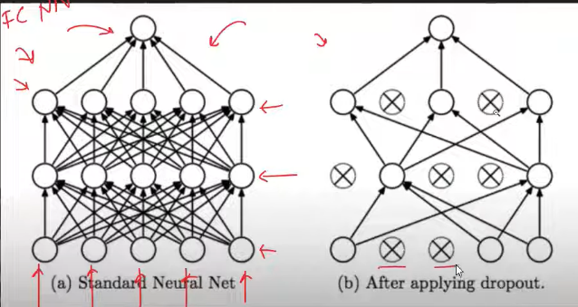

You randomly drop the input layer and hidden layer nodes.

For every epochs randomly nodes will be dropped out.

So , you can essentially change the architecture of your neural network for every different epochs.

So, you are reducing number of nodes by using p=0.5 which means in each layer half of node is dropped

Tips and Tricks

* Overfitting then increase p value underfitting then decrease
* Add dropout only for dropout

Drawbacks

* Convergence delay - training slow
* Loss function or cost function value changes

**Regularization in Deep Learning | L2 Regularization in ANN | L1 Regularization | Weight Decay in ANN**

* Used for reducing the Overfitting

Why overfitting- because of the complexity in the model as it captures every single thing.

* Ways to solve overfitting

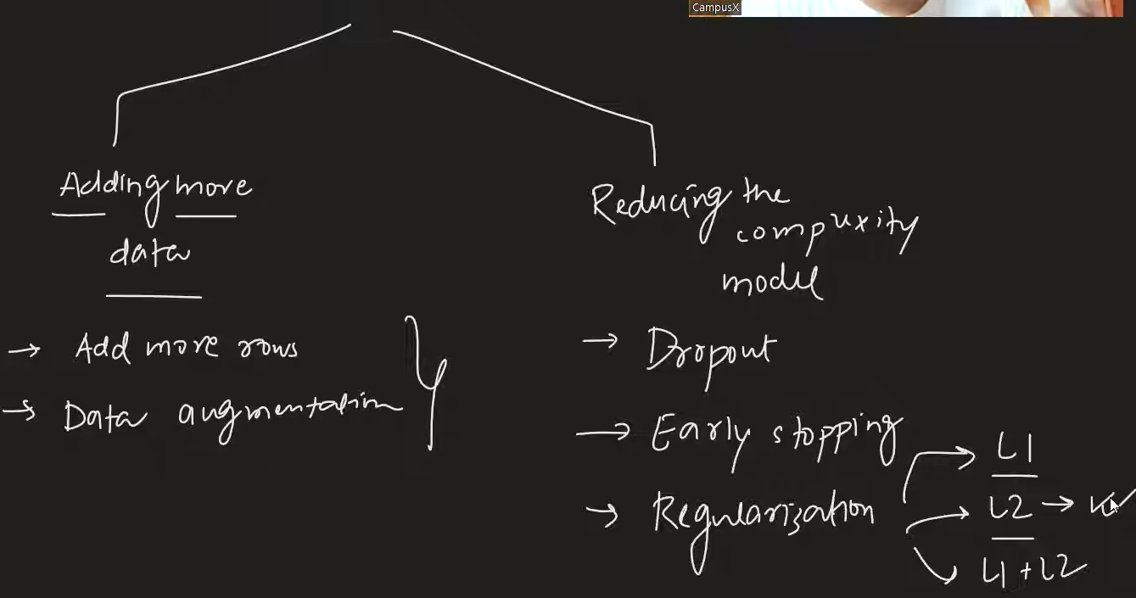

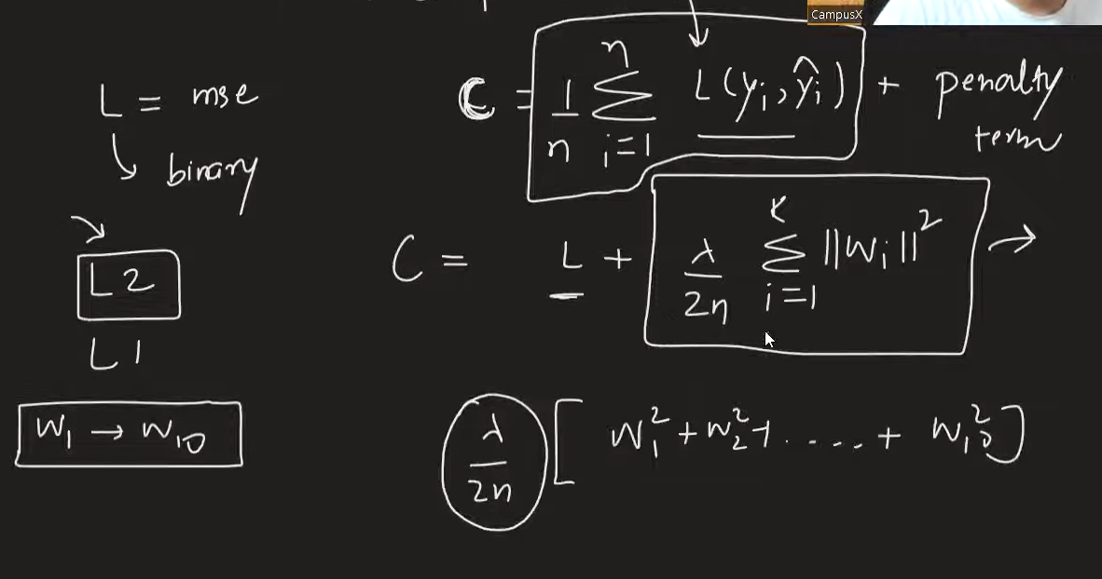L2 (in l1 square will nkt be) – you will not add biases 2

By adding the penalty term in the cost function , the value of weights start moving towards zero (0).but in l1 norm some of the weights may become zero as well.



**Activation Functions in Deep Learning | Sigmoid, Tanh and Relu Activation Function**

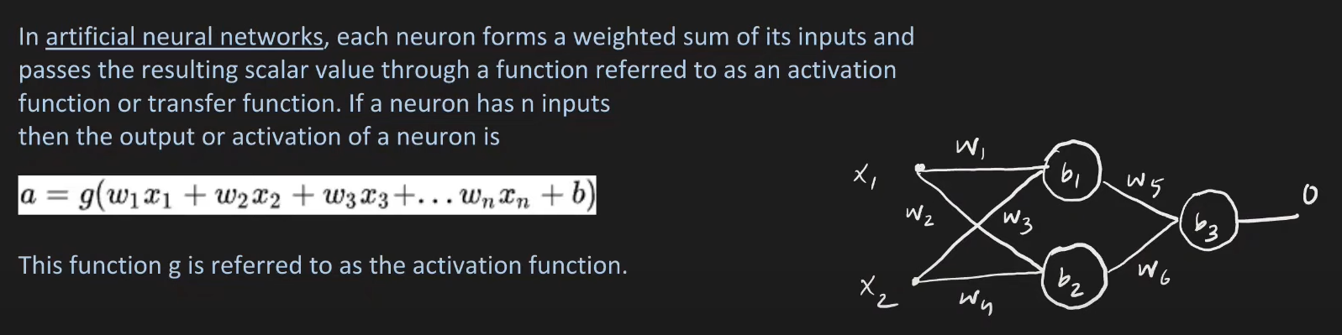

* A mathematical gate between input and output
* If you don’t use activation function then it is like you are performing linear regression or classification.

Why use?

If you use activation then you can perform regression or classification on non linear data as well.

* Ideal activation function Quality
  + - Non-Linear (like sigmoid)
    - It should be differentiable (bcz you use gradient descent)
    - Computationally inexpensive (calculating deriavative should be simple easy fast)
    - Zero centered (output should be normalized [mean 0] (tanh))
    - Non saturating – Should not squeeze the data like sigmoid 0 to 1 , tanh -1 to 1.

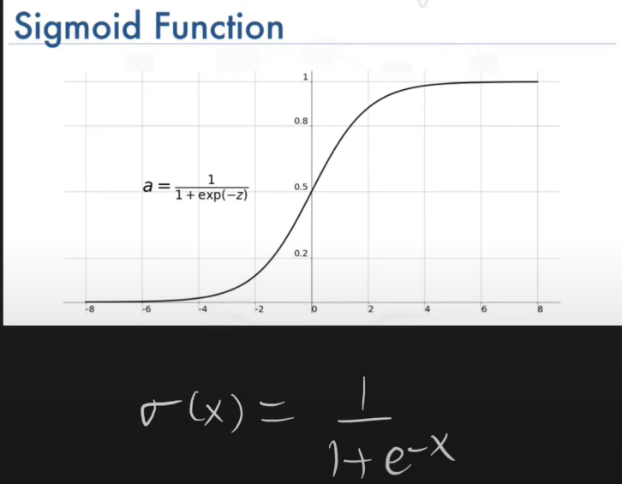Sigmoid

Pros

* Output 0 to 1
* Nonlinear Function
* Differentiable

Cons

* Saturating function (VGP Problem)
* Non zero centered(Convergence Pro)
* Computationally expensive bcz of the exp

Tanh

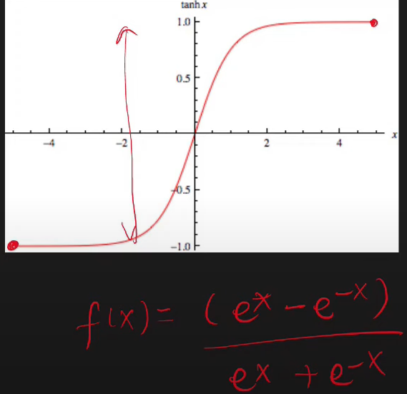Pros

* Non linear
* Differeinatable
* 0 centered (training faster)

Cons

* Saturating function VGP
* Computationally expensive

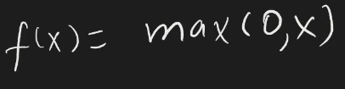

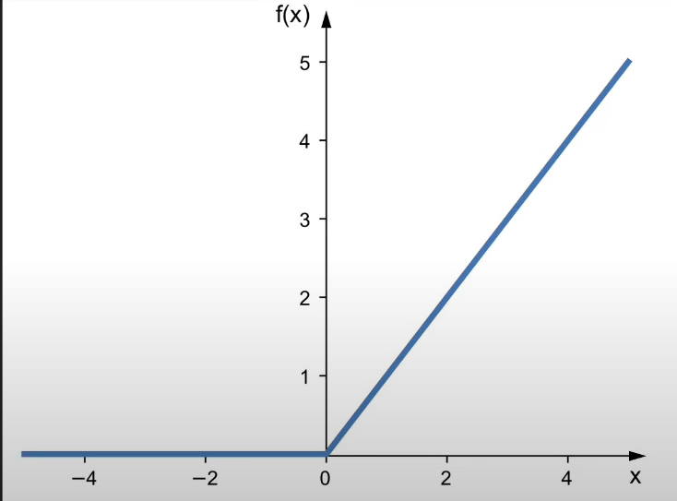Relu – Rectified linear unit

Pros

* Non linear
* Not saturated in positive region
* Computationally inexpernsive
* Convergence is faster

Cons

* Not completely differentiable
* Not Zero centered (we use batch normalization to solve)
* Dying relu

**Relu Variants Explained | Leaky Relu | Parametric Relu | Elu | Selu |**

Dying relu problem | why happens | how solved ?

* Output may become zero does not depend on input – dead neuron forever

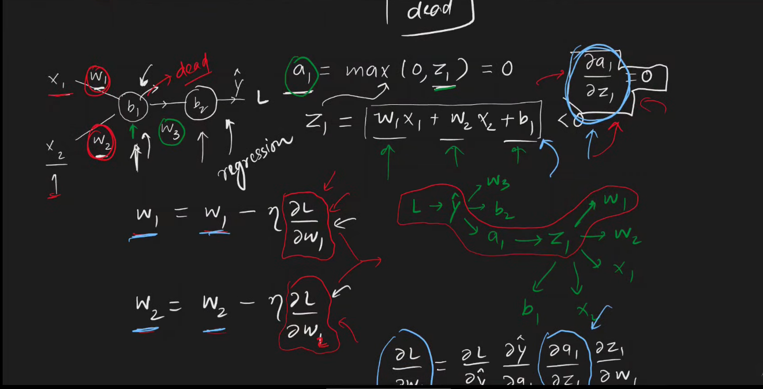

If the a1 becomes (negative or less than zero) then no weight updates happen as it derivates becomes zero.

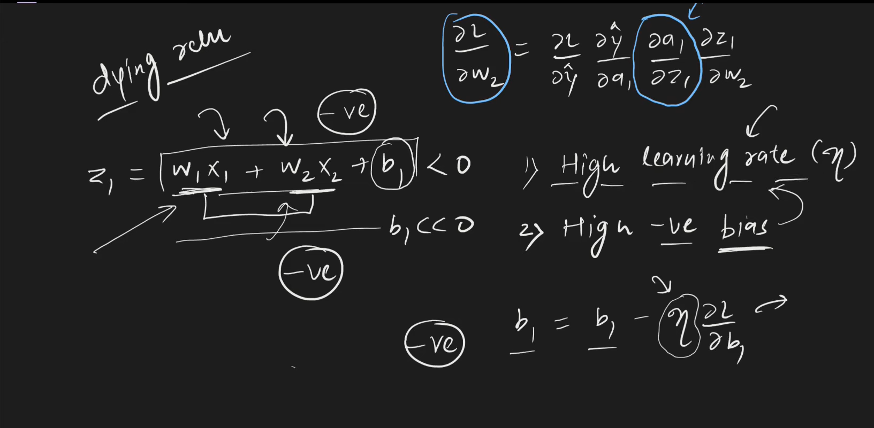

How to solve?

1 To set low learning rate

2 set biases as positive value 0.01

3 use relu variants

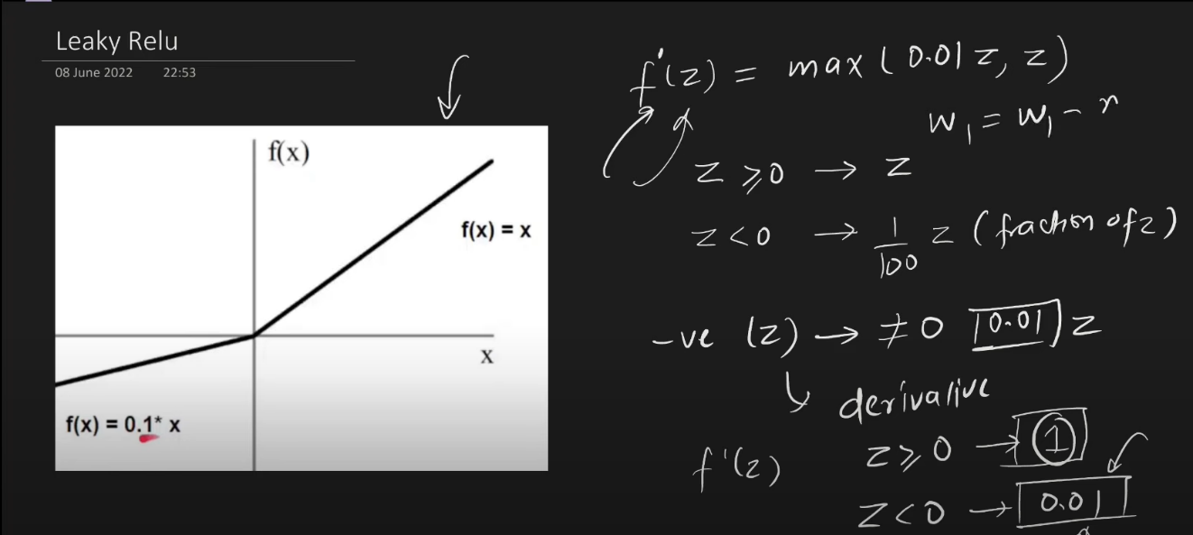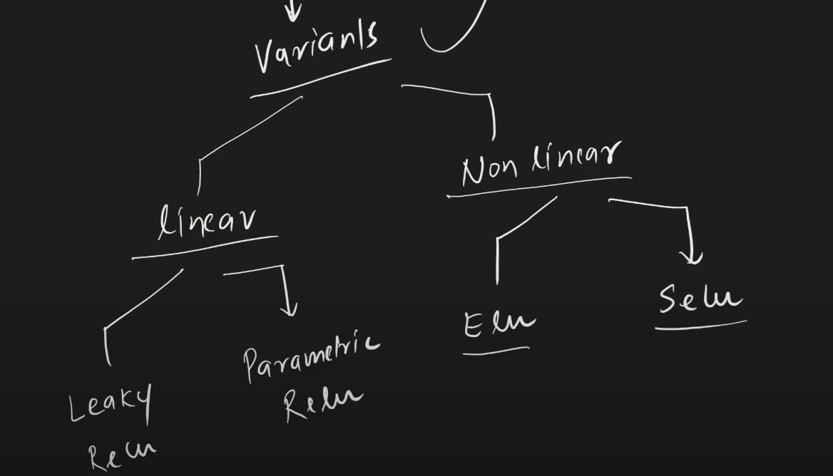

Pros

Not saturated

Easily computed

No dying relu problem

Close to zero

Centered

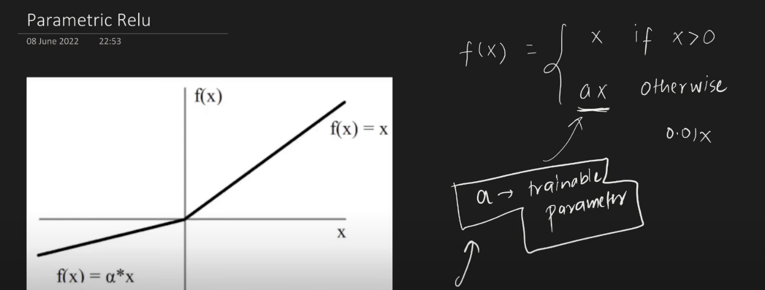

More flex

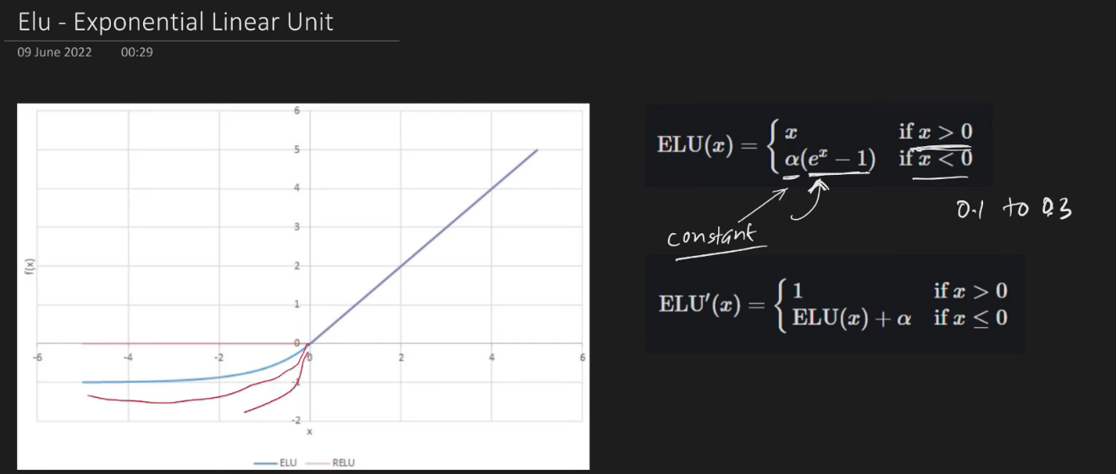Performance is better

Always differentiable

Close to 0

No dying relu problem

Dis -comput exp

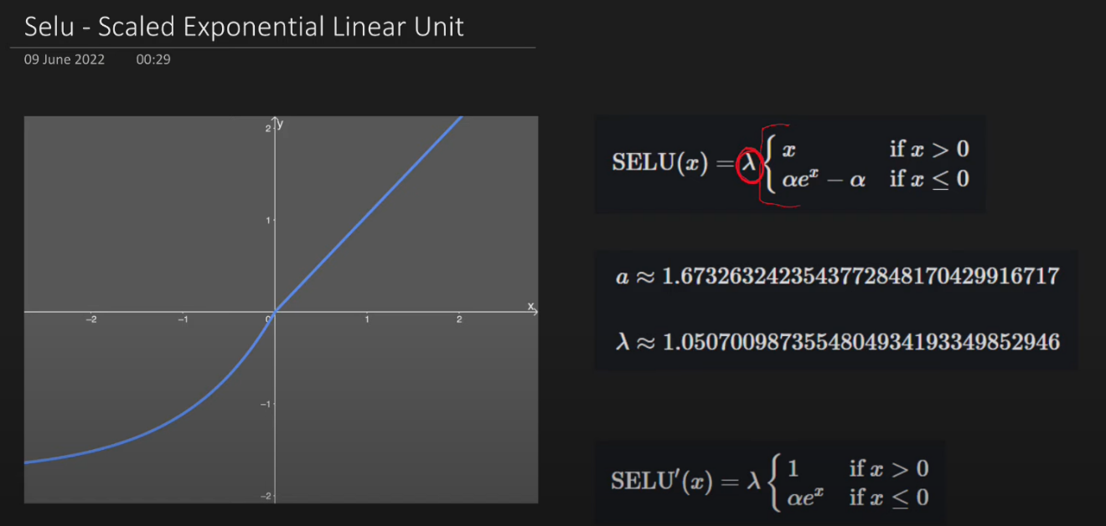

Self normalizing

Mean = 0 std=1

**Weight Initialization Techniques | What not to do?**

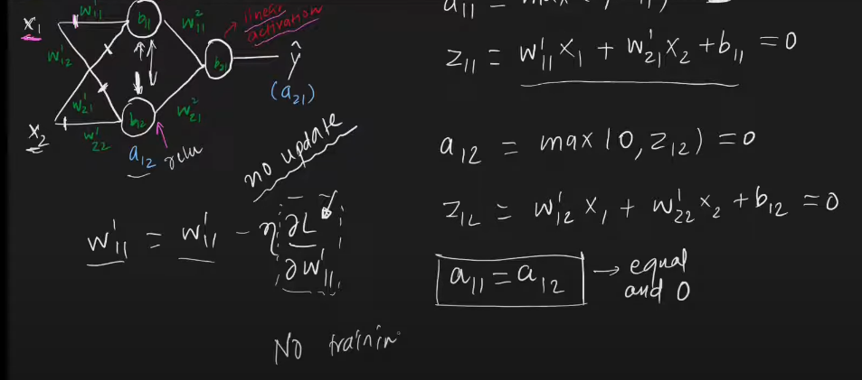Problem

* VGP
* EGP
* Slow Convergence

Case 1

If you take your activation function as relu,tanh and init weight and biases 0, then no training will happen.

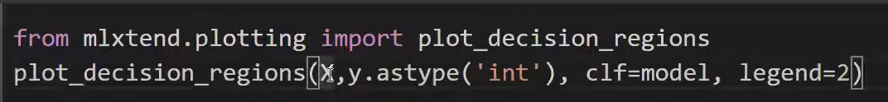

Plot Decision boundary

Using sigmoid with zero init , it will become linear model .

Case 2

Not init with non zero constant , it will behave same with sigmoid.

Case 3 Random init (small value)

Tanh – will give VGP using random init –(if use very small weights)

Same as sigmoid not much compared to tanh

Relu – training will be slow or convergence will be after more epochs.

Case 3 large values()

Slow training / VGP /saturation will happen / slow convergence

**Xavier/Glorat And He Weight Initialization**

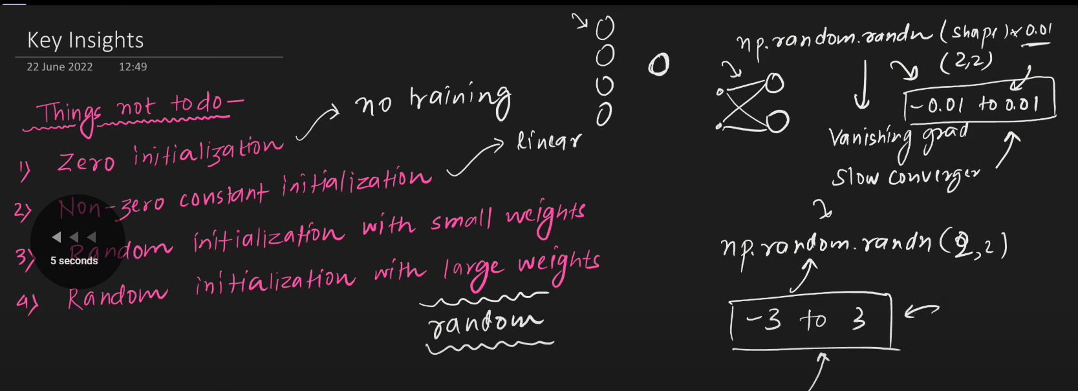

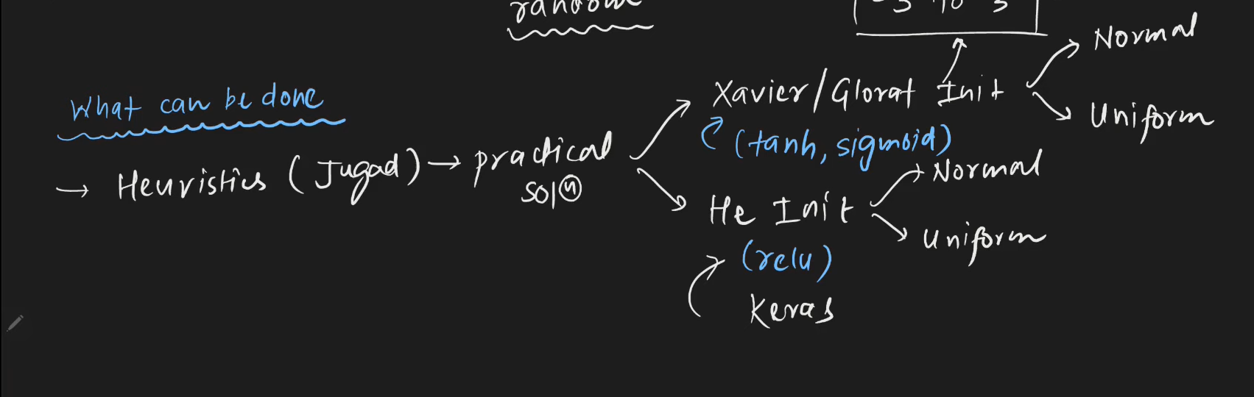

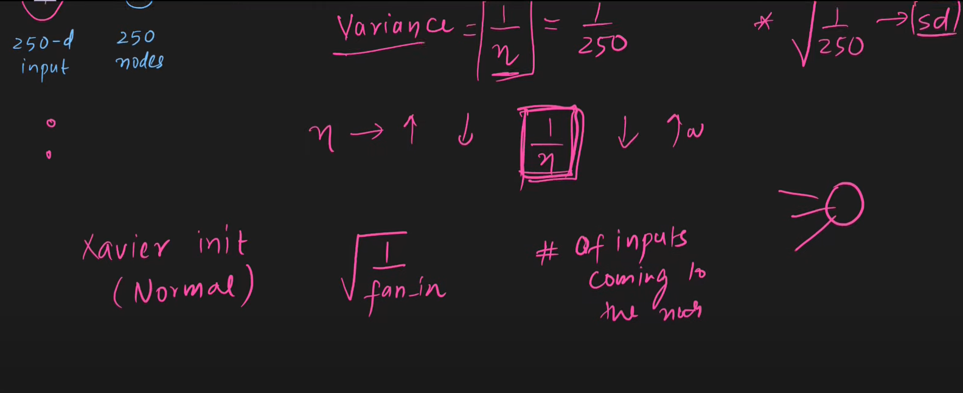

You will use tanh with xaveir

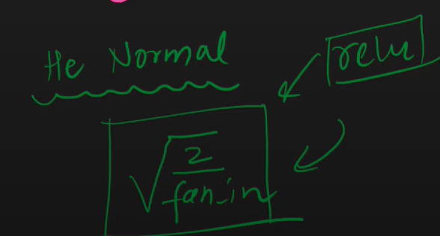

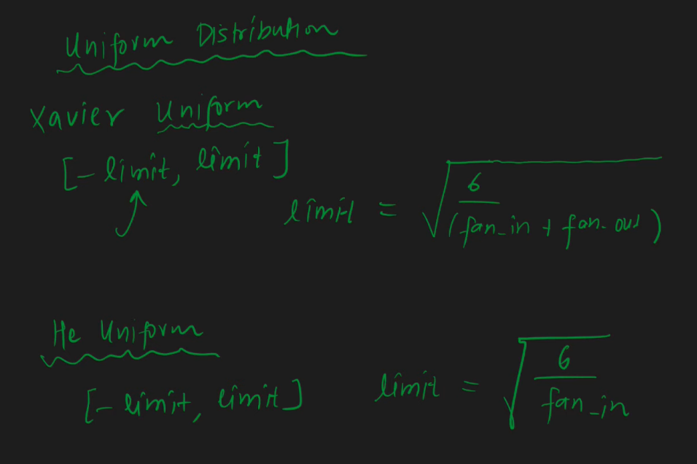

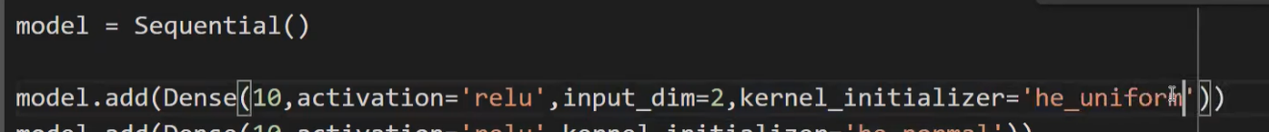

**Batch Normalization in Deep Learning | Batch Learning in Keras**

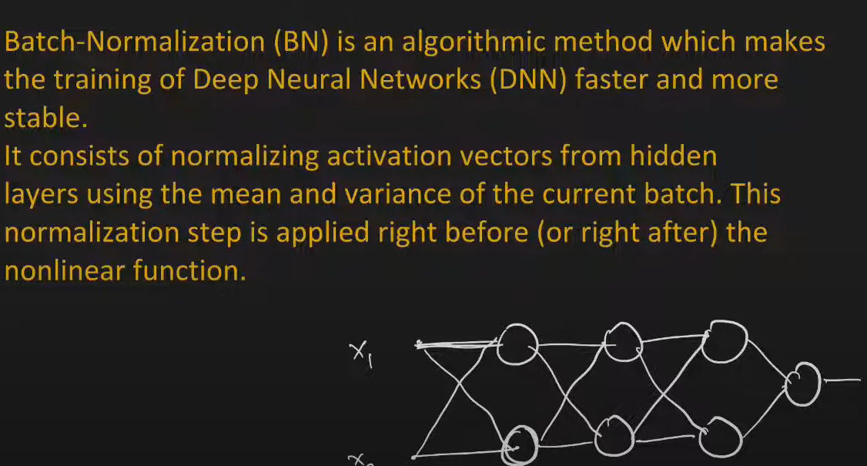

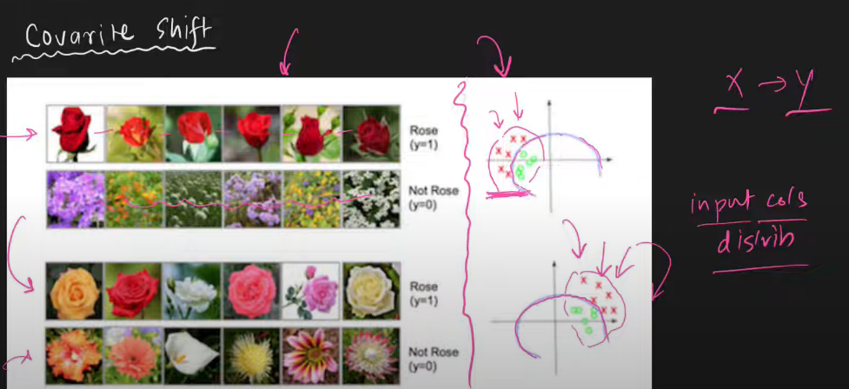Why use batch Norm?

Training faster and Stable

Covariate shift

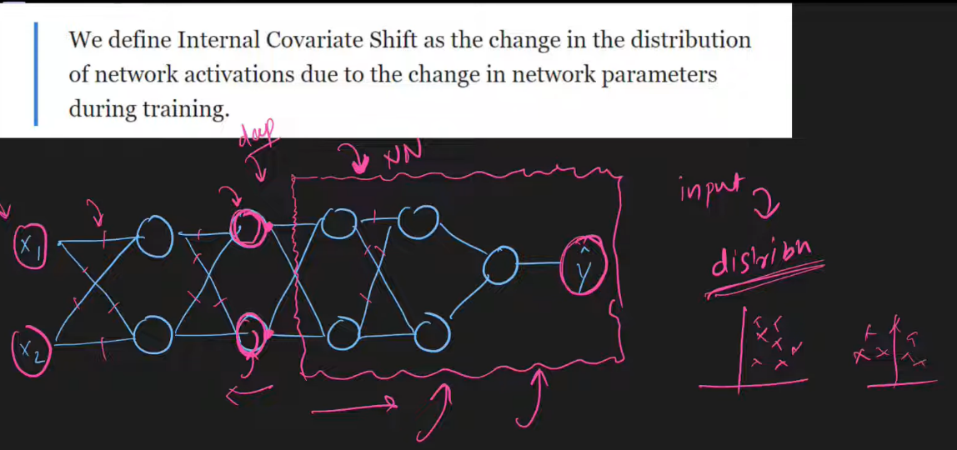Internal Covariate shift

Points to remember:

* When u apply Batch normailize u do with Mini BGD
* Layer by layer basis it is applied

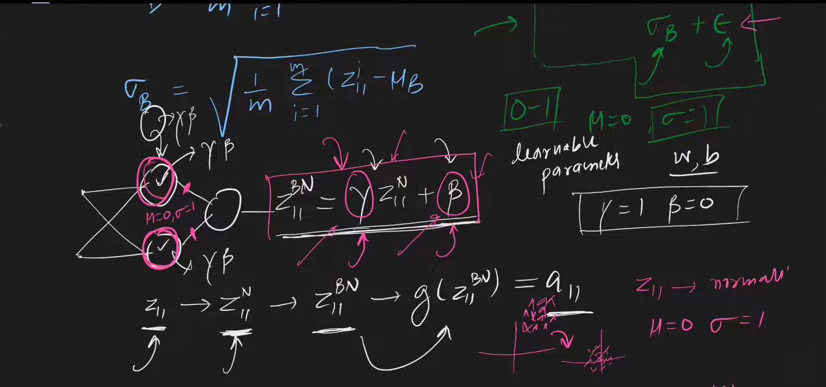

1 normailzation 2 scaling {gamma and beta will be for all nodes}

Advantages

>Stable

>Training Faster

>Act as Regularizaier

>weight init impact reduce

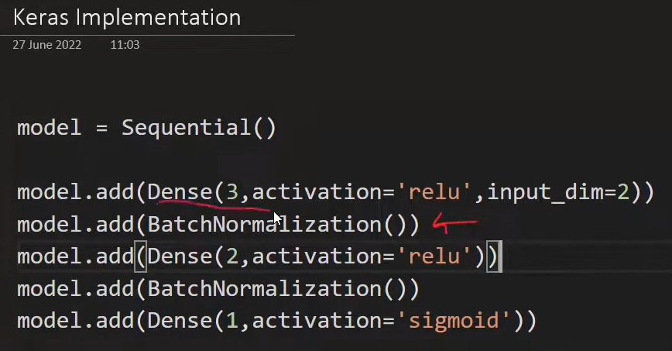

**Optimizers in Deep Learning | Part 1 |**

How to speed up Neural network

* Batch Normalization
* Weight init
* Activation function
* Optimizers

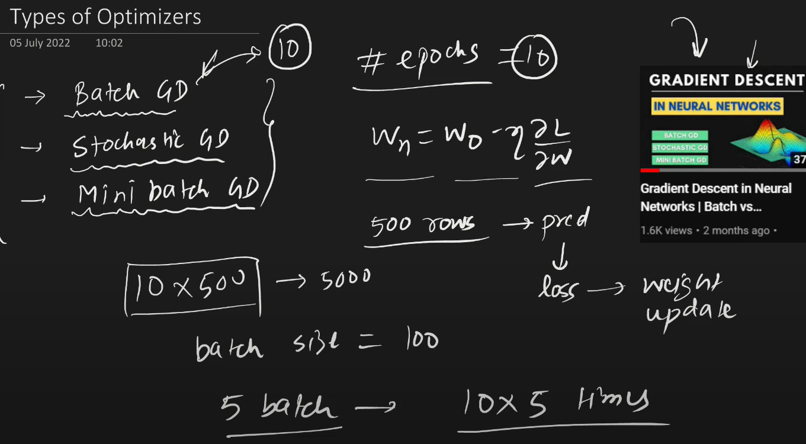

Challenee=ges 1

* Learning rate value difficult in GD
* LR scheduling – predefined
* You have to find multiple weights minimum in GD , the restriction is that we cant keep separate learning rate for all weights.
* Local minima
* Saddle point

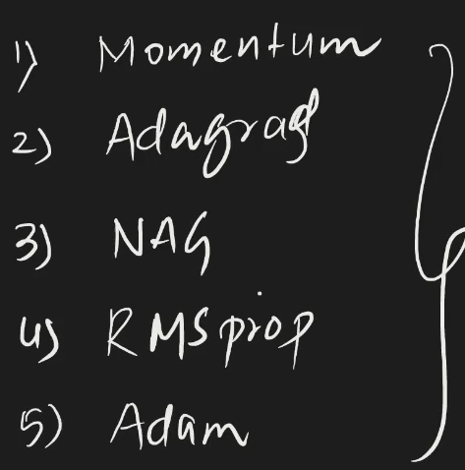

**Exponentially Weighted Moving Average or Exponential Weighted Average**

What?

Is a technique you find trends in time series data

* While calculating EWMA you value the next point more than previous
* After time passing the weightage will be reduce for that point

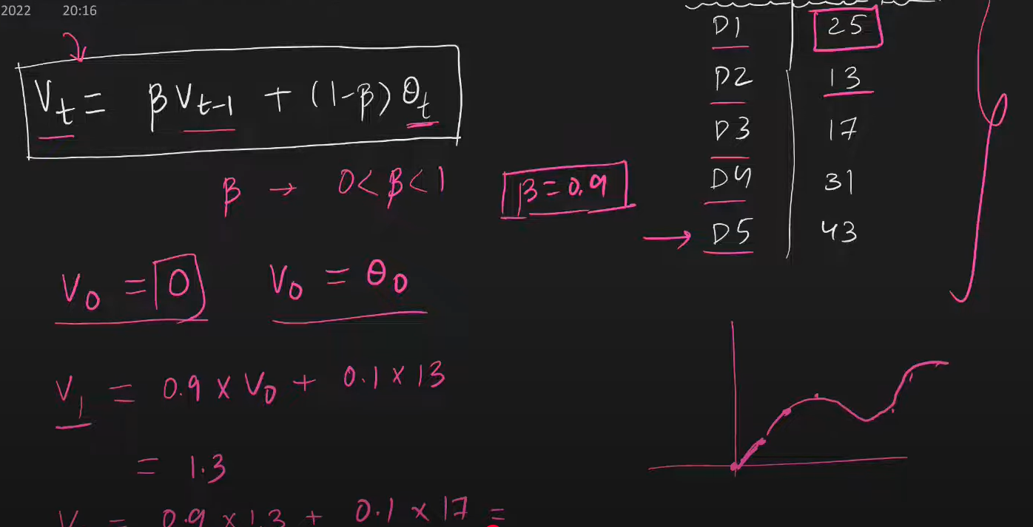

Vt – next B – paratmerete Q – current

The more B value , you will value the last point more.

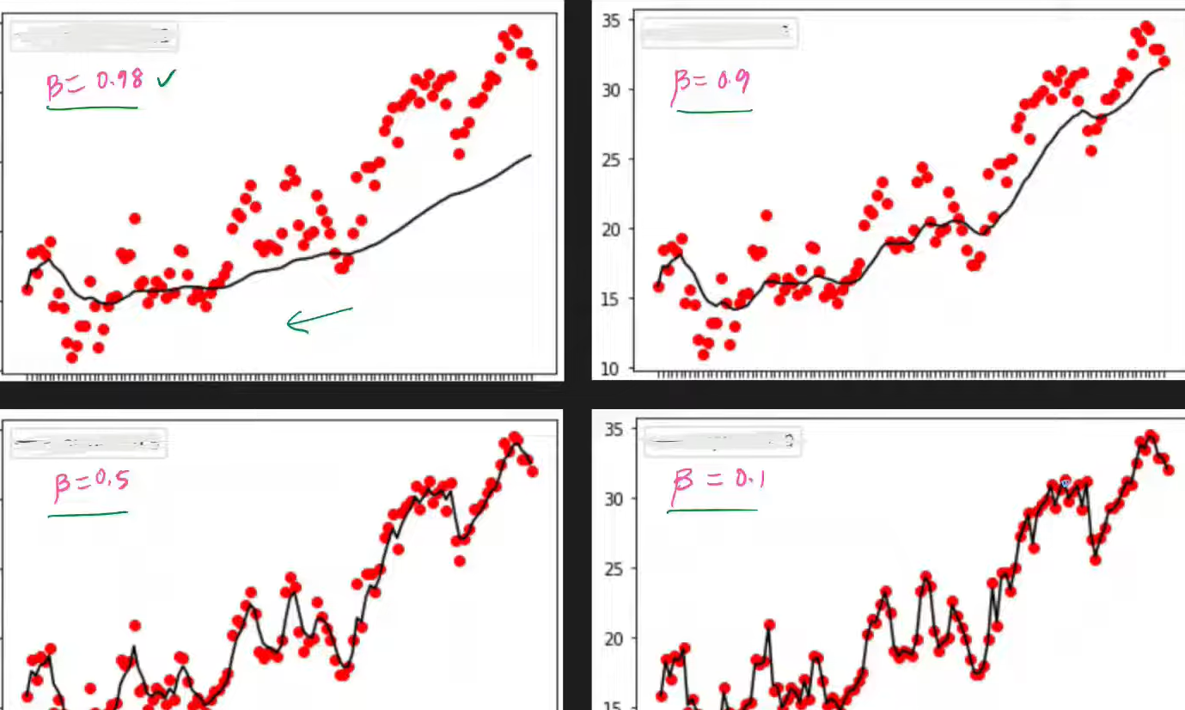

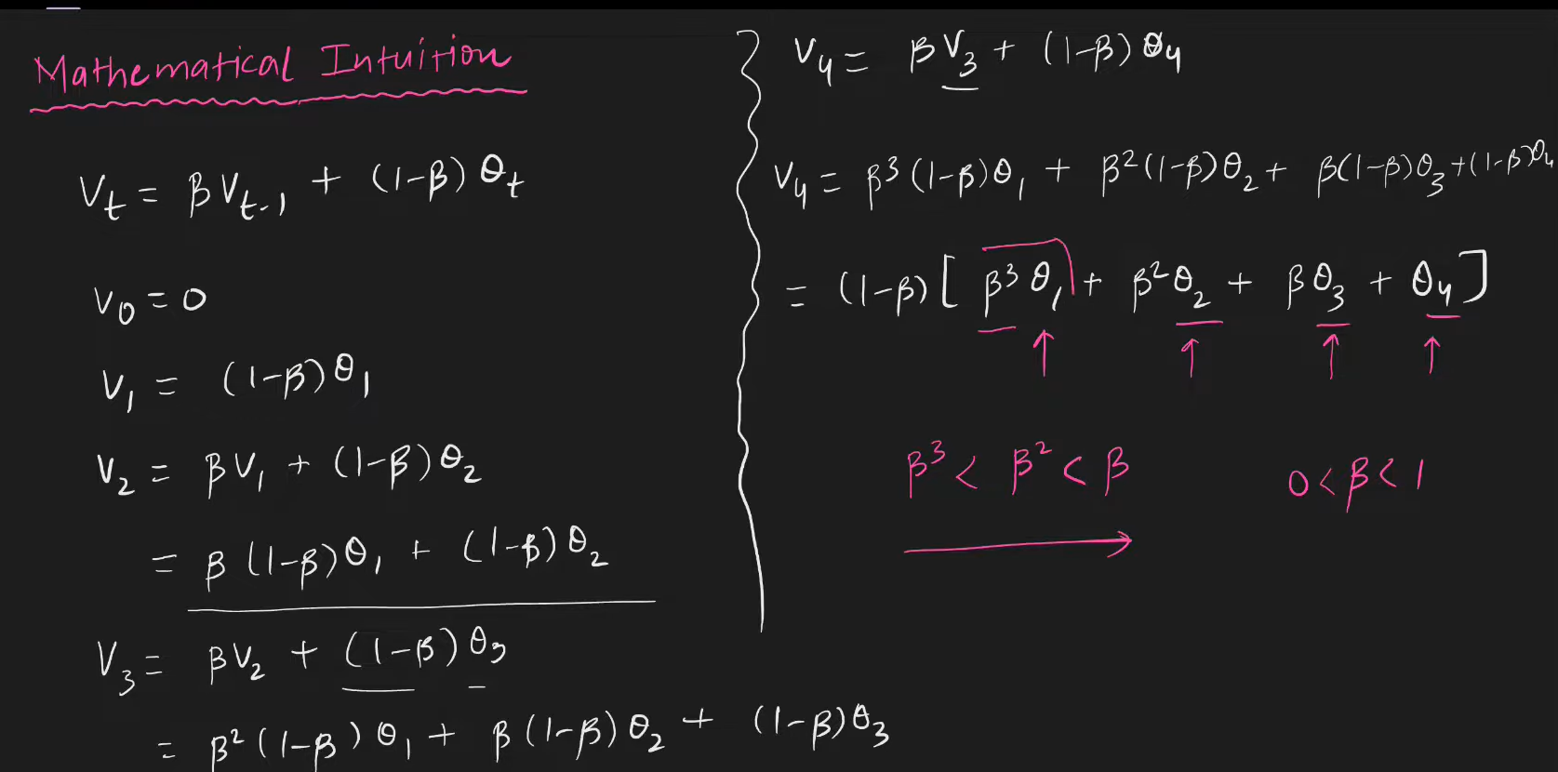

New value get more weightage compared to old , as formula is defined like this. So you get that kind of graph mentioned above.

**SGD with Momentum**

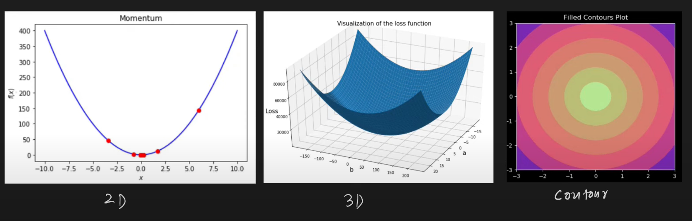

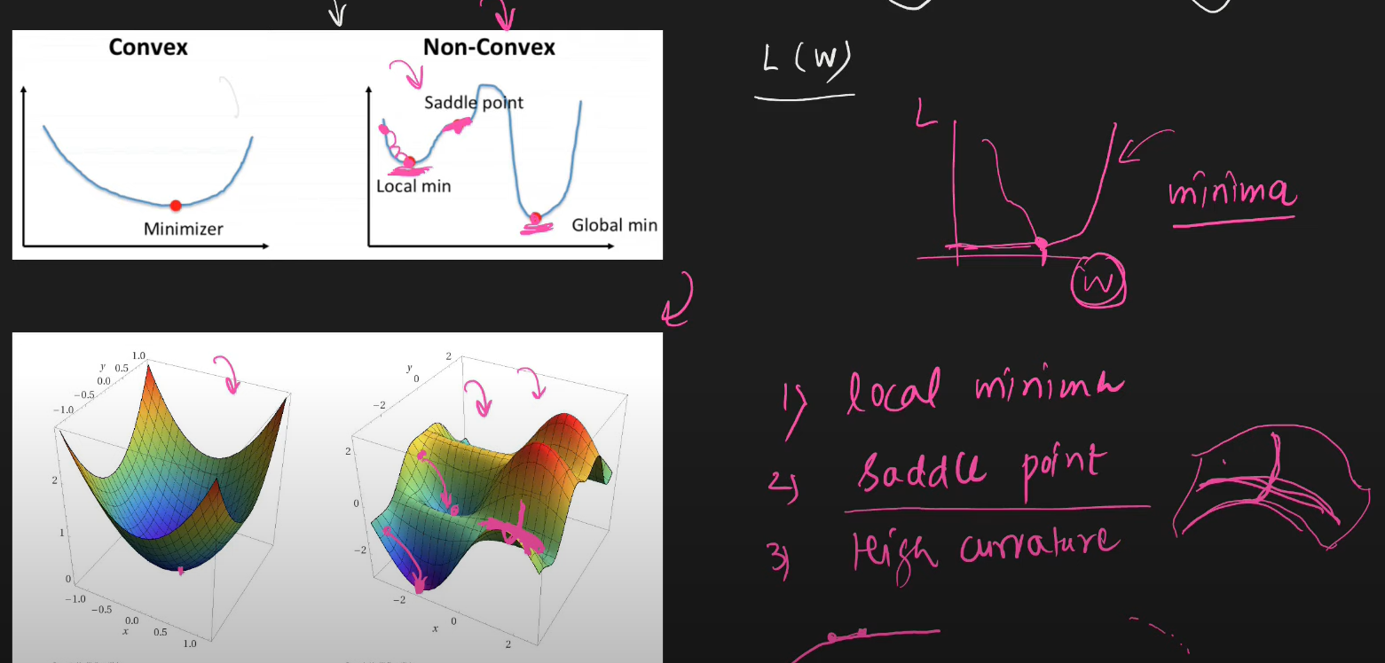

Momentum Optimization?

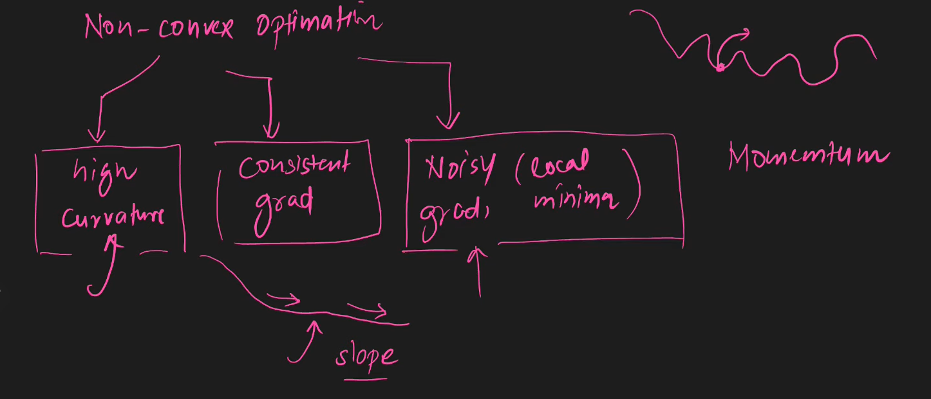

The idea is if ur previous gradients making you move towards in same direction then you will speed up in that direction.

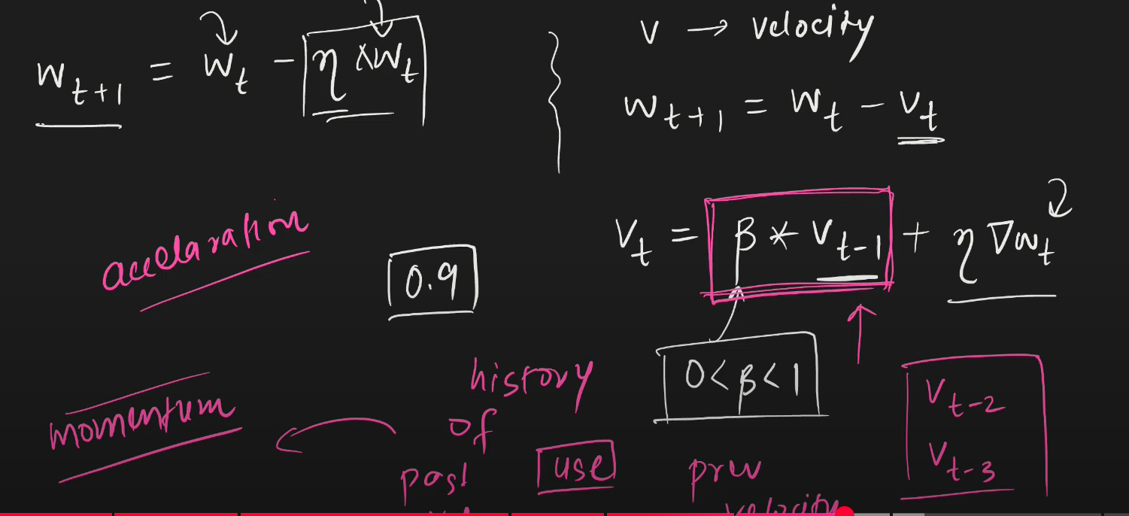

Benefit

* Faster
* Local minima escape [https://miro.medium.com/v2/resize:fit:800/1*zVi4ayX9u0MQQwa90CnxVg.gif](https://miro.medium.com/v2/resize:fit:800/1*zVi4ayX9u0MQQwa90CnxVg.gif)

Disad

* It will start oscillates check the link above

**Nesterov Accelerated Gradient (NAG)**

* Bascially implementing momettum technique only but with an improvement that you dramp the oscialltions (reduce the oscailltions)

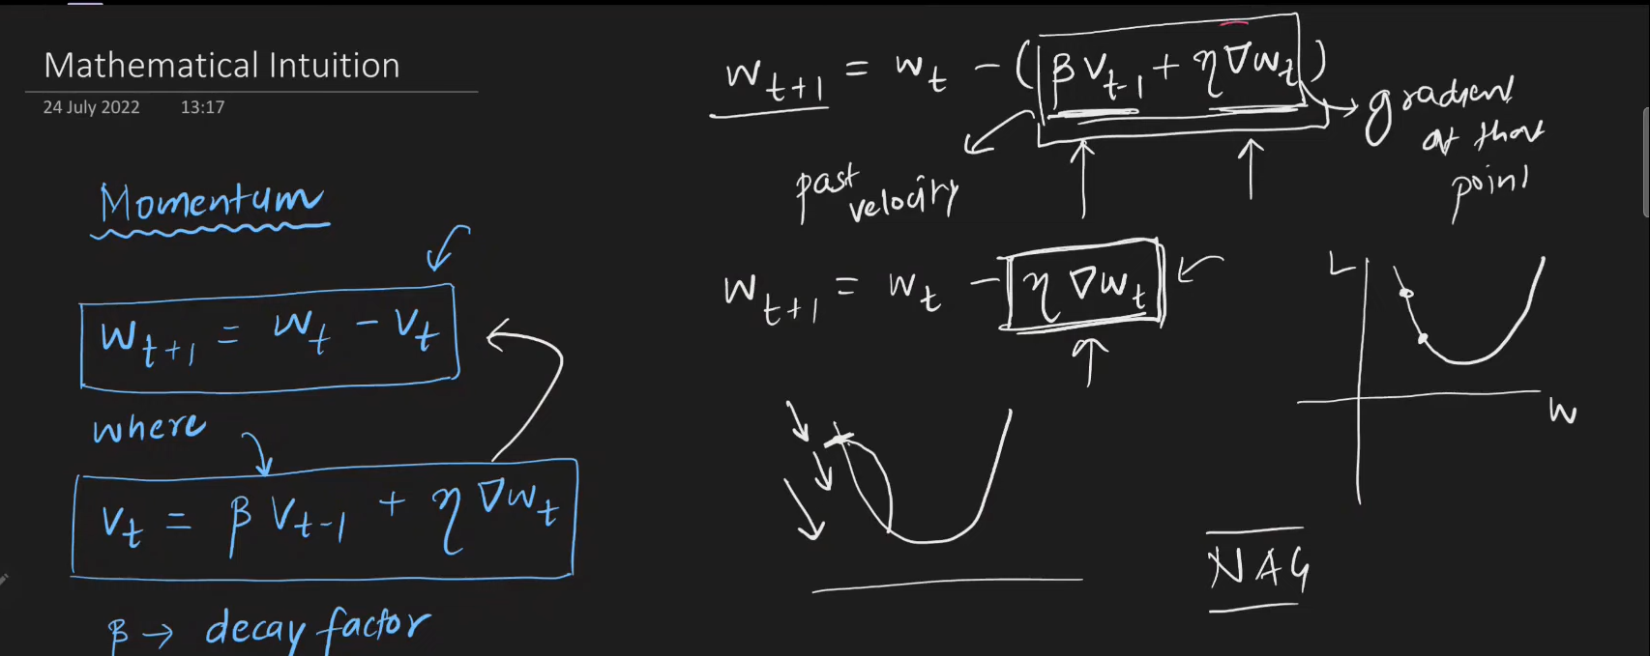

* In nag you will take the momentum jump first and after that jump we ‘re you reach you calculate gradient from that point where as in momentum both happen together.

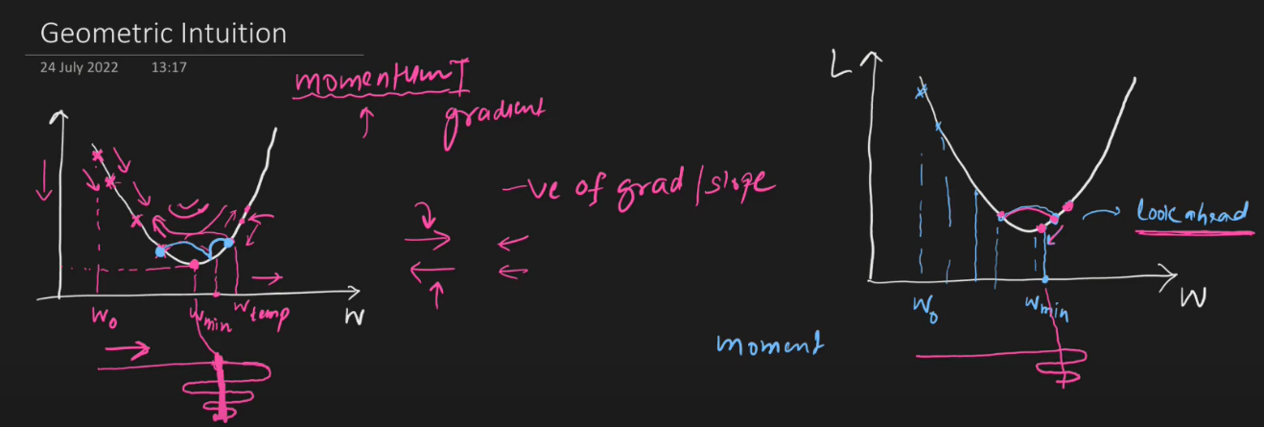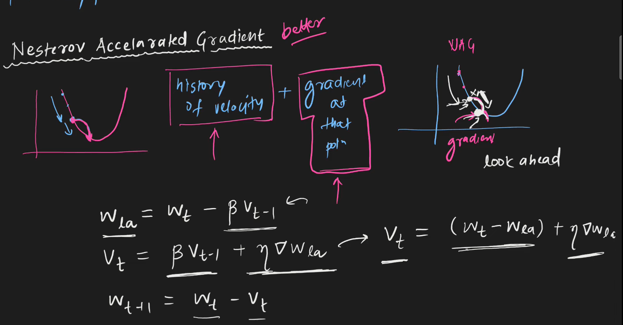

Disadvanatgaes

* Local minima stuck

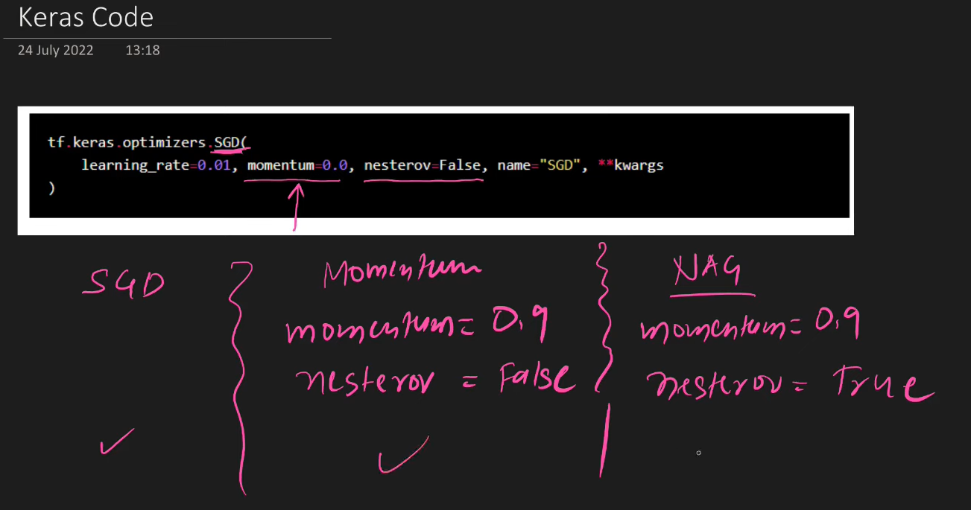

**AdaGrad Explained**

* Adaptive Gradient
* You will not keep the learning rate fix
* Adagrad work well when
  + - * Input feature scale is different
      * Features are sparse (values are 0)

Having sparse feature you will face a problem called elongated bowl problem.

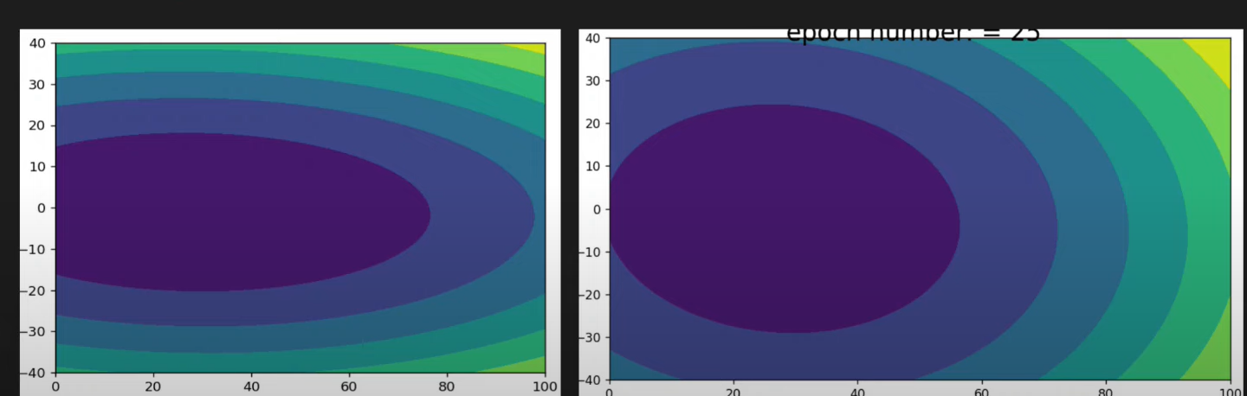

1 axis – slope change and 1 not in elongated graph.

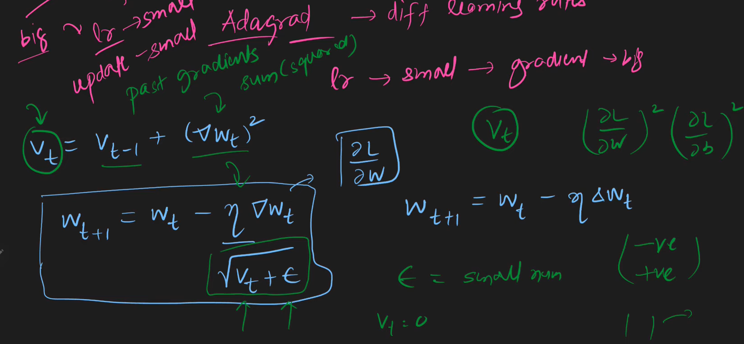

Disadvantages

* It will reach near to solution not to solution because of the learning rate is decreasing value.
* Work good with linear only.

**RMSProp Explained**

* Root mean square propagation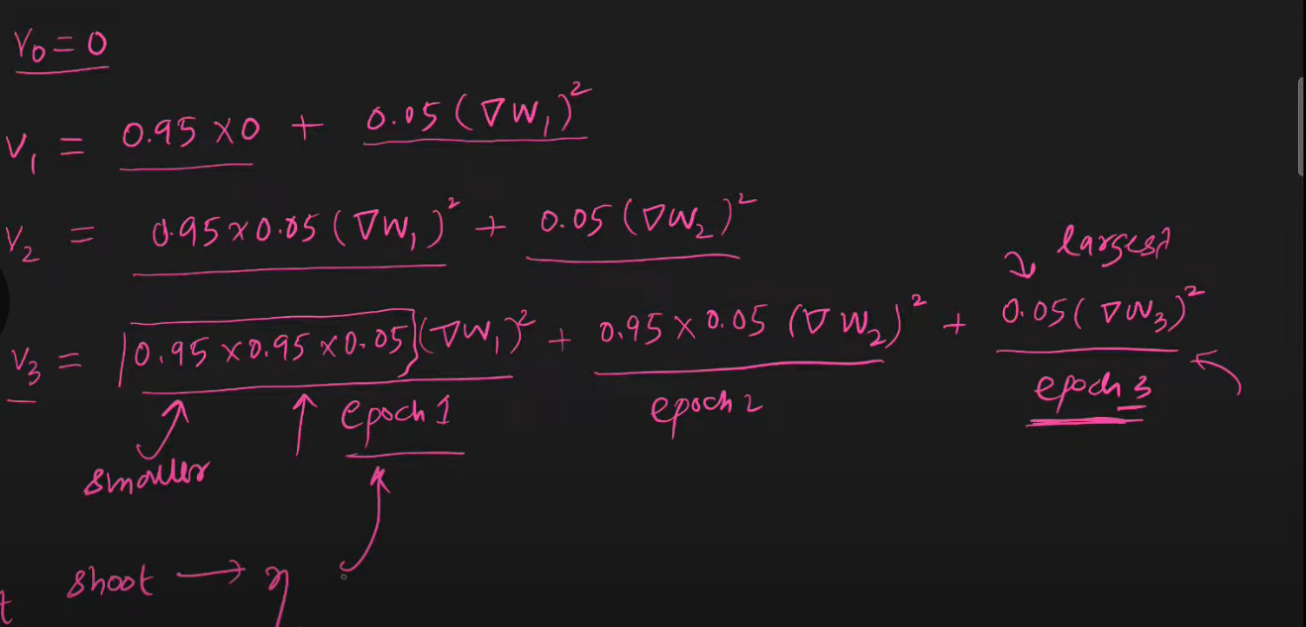 Improvement of Adagrad

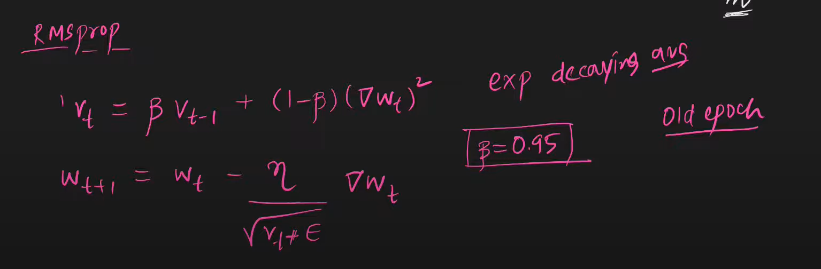

Disadvantages

* No , it is best optimization technique , used less because of new ADAM

**Adam Optimizers**

* Adaptive moment estimation
* Is the combination of momentum and learning decay

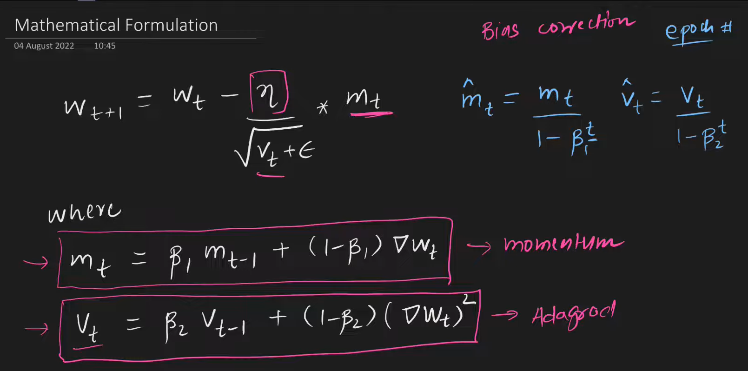

Other are also there like adadelta and so on.

Adam > RMSPROp > Momentum

(Always do hyper parameter tuning to check which is working good.)

**Keras Tuner | Hyperparameter Tuning a Neural Network**

KerasTuner is an easy-to-use, scalable hyperparameter optimization framework that solves the pain points of hyperparameter search. Easily configure your search space with a define-by-run syntax, then leverage one of the available search algorithms to find the best hyperparameter values for your models. KerasTuner comes with Bayesian Optimization, Hyperband, and Random Search algorithms built-in, and is also designed to be easy for researchers to extend in order to experiment with new search algorithms.